# Charter

National Water Quality Management Strategy

2018

© Commonwealth of Australia 2018

**Ownership of intellectual property rights**

Unless otherwise noted, copyright (and any other intellectual property rights, if any) in this publication is owned by the Commonwealth of Australia (referred to as the Commonwealth).

**Creative Commons licence**

All material in this publication is licensed under a Creative Commons Attribution 3.0 Australia Licence, save for content supplied by third parties, logos and the Commonwealth Coat of Arms.

C:\Documents and Settings\west merryn\Local Settings\Temporary Internet Files\Content.Word\by.png

Creative Commons Attribution 3.0 Australia Licence is a standard form licence agreement that allows you to copy, distribute, transmit and adapt this publication provided you attribute the work. See the [summary of the licence terms](http://creativecommons.org/licenses/by/3.0/au/deed.en) or the [full licence terms](http://creativecommons.org/licenses/by/3.0/au/legalcode).

Inquiries about the licence and any use of this document should be emailed to [copyright@agriculture.gov.au](mailto:copyright@agriculture.gov.au).

**Cataloguing data**

This publication (and any material sourced from it) should be attributed as: Australian Government 2018, *Charter: National Water Quality Management Strategy*, Department of Agriculture and Water Resources, Canberra, March. CC BY 3.0.

This publication is available at [waterquality.gov.au](http://www.waterquality.gov.au/).

Department of Agriculture and Water Resources

Postal address GPO Box 858 Canberra ACT 2601

Telephone 1800 900 090

Web [agriculture.gov.au](http://agriculture.gov.au/)

The Australian Government acting through the Department of Agriculture and Water Resources has exercised due care and skill in preparing and compiling the information and data in this publication. Notwithstanding, the Department of Agriculture and Water Resources, its employees and advisers disclaim all liability, including liability for negligence and for any loss, damage, injury, expense or cost incurred by any person as a result of accessing, using or relying upon any of the information or data in this publication to the maximum extent permitted by law.

Contents

National Water Quality Management Strategy glossary 1

1 Introduction 4

2 Background to the NWQMS 5

3 Purpose of this document 7

4 Overview of the NWQMS 8

4.1 The Strategy 8

4.2 The objective 8

4.3 The scope 8

4.4 The logic 8

4.5 Responsibility for the NWQMS 9

4.6 Effectiveness of the NWQMS 9

4.7 NWQMS tools and information 10

4.8 NWQMS Guidelines 10

5 Water Quality Management Framework 12

5.1 About the Water Quality Management Framework 12

6 Key steps in the Water Quality Management Framework 13

6.1 Current understanding 13

6.2 Identifying community values and management goals 14

6.3 Identifying water quality objectives 15

6.4 Identify whether there is a need for improvement or maintenance 15

6.5 Management strategy 16

6.6 Implement the strategies 16

6.7 Monitoring and evaluation 16

7 More information 17

8 Attachment A: Indigenous cultural and spiritual values 18

8.1 Introduction 18

8.2 Incorporating Indigenous cultural and spiritual values in water quality planning 18

8.3 Further information 19

9 References 20

**Figures**

Figure 1 NWQMS logic 9

Figure 2 Water Quality Management Framework 12

Figure 3 Examples of pressures, stressors and responses 13

Figure 4 Steps for incorporating cultural and spiritual values into water quality planning 19

## National Water Quality Management Strategy glossary

|  |  |
| --- | --- |
| Community Values | A particular value or use of the environment that is important for a healthy ecosystem or for public benefit, welfare, safety or health and that requires protection from the effects of stressors. Community values include:  **Aquatic ecosystems**  Water quality that will provide a healthy environment for the ecological communities that live in the water or are dependent on water resources. Aquatic ecosystems compromise the animals, plants and micro-organisms that live in water and the physical and chemical environment and climatic regime with which they interact.  **Cultural and spiritual values**  Water quality that will take into account cultural and spiritual values (further information about principles of Indigenous cultural and spiritual values is at  Attachment A).  **Drinking water**  Water quality suitable for the purpose of human consumption  **Industrial water**  Water quality suitable for industrial use—for example, mining, manufacturing and electricity generation.  **Primary industries**  Water quality suitable for irrigation, stock drinking water, aquaculture and human consumers of aquatic foods.  **Recreation and aesthetics**  Water quality suitable for purposes such as swimming and rowing and that will provide visual amenity.  Community values are also known as ‘environmental values’ or ‘beneficial uses’. |
| Fit for purpose | The aim of achieving water quality that will be suitable for the current (or desired) uses and values. |
| Guideline | A document that provides information and guidance on how to deal with a specific issue. |
| Guideline value | A measurable quantity (for example, concentration) or condition of an indicator for a specific community value below and/or above which (such as in the case of stressors such as pH, dissolved oxygen and many biodiversity responses) there is considered to be a low risk of unacceptable effects occurring to that environmental value.  **Default guideline value**  A guideline value recommended for generic application in the absence of a more specific guideline value. |
| Indicator | A parameter that can be used to provide a measure of a pressure, stressor and/or response. |
| Management Goal | A measure or statement used to assess whether community values are being protected. It should reflect the desired level of protection and provide precise and detailed descriptions of the community values to be protected. |
| Management Strategy | Documentation of actions and approaches to achieve the water quality objectives and management goals and, hence, protect the community values. |
| Pressure | Any human activity or biophysical pattern of change that has the potential to impact on the natural environment. |
| Stressor | Any physical, chemical or biological substance or process arising from a pressure that has the potential to induce an adverse environmental response to a community value. |
| Response | The physical, chemical or biological impact on community values. |
| Water quality | The physical, chemical and biological characteristics of water and the measure of its condition relative to the requirements for one or more biotic species and or to any human need or purpose. |
| Water Quality Objective | The guideline value and/or narrative statement for each selected indicator that should ensure the protection of all identified community values. This can include setting guideline values to maintain water quality (which could also be termed intermediate Water Quality Objectives) and/or to improve water quality (which could also be water quality targets or aspirational Water Quality Objectives). |
| Water Quality Target | Numerical levels or descriptive statements that should be met to protect environmental values within a specified time frame. Targets should have regard for current condition and, where possible, long-term trends in water quality. |

## Introduction

Water is a vital part of life. People, the environment, agriculture and industry all depend on the supply of water. It is also important to have the right quality of water so that it can be used for the desired purposes. For example, water for drinking will need to be a higher quality than for some agricultural purposes. Understanding water quality is a critical component of using and managing water resources.

Managing water quality and quantity in Australia raises some challenging issues. Variations in climate, topography and geology, combined with changes to land and water use, make understanding the current situation and how to achieve the desired outcomes complex. Information and tools to assist with this task are essential to improving water quality management in Australia.

The National Water Quality Management Strategy (NWQMS) aims to assist water resource managers to understand and protect (which could be maintain or improve) water quality so that it is ‘fit for purpose’—that is, water that is suitable for the desired values and uses and the specific local conditions. The NWQMS can also support the integration of water quality into water quantity planning. A range of tools and guiding documents to assist in improving water quality and reducing pollution are available under the NWQMS. More information about the NWQMS is available on the [NWQMS website](http://www.waterquality.gov.au/).

In Australia, the primary responsibility for water quality management lies with state and territory governments, except for areas like Commonwealth marine waters. The Australian Government works with all states and territories to provide the best available information to support state and territory governments in establishing their own guidelines and regulations for managing the quality and supply of water that is fit for purpose.

The NWQMS represents an effective collaborative process in which a national, multiple-level government approach towards a specific outcome can be achieved without need for national regulatory standards. This charter describes the NWQMS, how it works and how it is managed by governments.

## Background to the NWQMS

The NWQMS was introduced in 1992 and incorporated into the Council of Australian Governments (COAG) Water Reform Framework in 1994. It contributed to the development of a national policy to sustainably manage Australia’s water resources by protecting and enhancing their quality while maintaining economic and social development. The NWQMS follows the guiding principles set out in the National Strategy for Ecologically Sustainable Development, which was also endorsed by COAG in 1992.

Since then the NWQMS has grown and improved through collaboration between the Australian, state and territory governments, peak bodies and other stakeholders to develop guidelines and tools to assist with water quality management. While the NWQMS is non-mandatory, it is utilised by all state and territory governments in establishing their own guidelines, regulations, policies, processes and/or standards for managing the quality and supply of water that is fit for purpose. The Australian Government also utilises the NWQMS for various purposes such as meeting international obligations.

The 2004 Intergovernmental Agreement on a National Water Initiative, Australia’s blueprint for water reform, recognised that continued implementation of the NWQMS would complement the outcomes of the agreement. The National Water Initiative’s continued implementation has been supported by the use of NWQMS tools in key areas such as environmental watering planning. The Murray–Darling Basin Plan also uses information from NWQMS guidelines to set water quality targets and objectives for catchments within the basin.

It is important that, as water resources policy addresses the competing pressures on water availability, water quality is also taken into account. Often the lack of water, such as through a drought, will also impact on the quality of the available water. This can be critical when planning for emergency situations. Conversely, too much water can lead to flooding and ‘blackwater events’. This is where large amounts of organic matter wash into waterways, depleting the oxygen dissolved in the water and sometimes leading to the death of fish and other aquatic organisms. The NWQMS and other reference materials assist in the complex management of water resources for human and environmental needs.

The collaborative approach to the NWQMS has reduced duplication and achieved consistency in approaches across states and territories. This has resulted in the NWQMS providing the best available science to support decision making while incorporating flexibility to tailor the information to local conditions. It meets the need of governments, industry and organisations to manage water so that it is fit for purpose.

Reviews of the NWQMS have continued to find that it is an effective mechanism for managing water quality. A review of implementation of the NWQMS in 2008 by John Bennett found that the NWQMS provided a good framework for managing water quality and sound technical references to support water quality management. There was also a good range of examples of water quality management plans at the catchment level that utilised the framework and tools from the NWQMS such as environmental values, water quality guideline values and effective management strategies. An independent review of the NWQMS conducted by the organisation KPMG in 2011 to evaluate the appropriateness of the NWQMS in water reform policy and the efficiency and effectiveness of its implementation found that water quality continues to be an issue that requires national policy intervention.

A key issue highlighted in the review was that the policy outline had not been updated in over 20 years. The KPMG review also recommended improvements to the NWQMS in structure, governance, implementation and monitoring. While knowledge and expertise on managing water quality has grown, the key NWQMS documents have not captured this information.

## Purpose of this document

This charter provides a revised and updated NWQMS policy to provide a clear rationale for the NWQMS in Australia’s water policy.

## Overview of the NWQMS

### The Strategy

The NWQMS strategy is to develop and maintain a voluntary, nationally coordinated framework, supported by all Australian governments, to facilitate water quality management for the productive and sustainable use of Australia’s water resources and to protect community values such as aquatic ecosystems. The NWQMS consists of nationally agreed policies, guidelines and tools to assist governments, and other organisations and institutions, to manage water quality, taking account of local conditions and community values. Community values are also known as ‘environmental values’ or ‘beneficial uses’.

### The objective

The objective of the NWQMS is to enable effective water quality management for the delivery of fit-for-purpose water that supports community values.

### The scope

The NWQMS provides information that is applicable to all types of water in Australia, including fresh water, marine water, groundwater, estuarine water and recycled water; and that will support different purposes of the water, such as for drinking, the environment, primary industry, recreation, industry and cultural and spiritual values. Some NWQMS information is also relevant to New Zealand and is utilised by the New Zealand authorities.

The NWQMS provides guidance and policy on water quality management, particularly about the quality of water that will be fit for purpose. Documents developed under the NWQMS to assist water quality management can be found on the [NWQMS website](http://www.waterquality.gov.au/).

### The logic

The NWQMS logic (see Figure 1) gives an overview of how the NWQMS works, including the issues the NWQMS is designed to address (for example, material input or change (including quantity) which reduces environmental health; and a fragmented approach/risks to management) and the outcomes for water quality that it aims to achieve (for example, water that is fit-for-purpose).

The main centre box shows the key components, roles and responsibilities under the NWQMS, including:

* the nationally agreed policy, framework and tools that are the responsibility of COAG and Australian, state and territory governments to deliver
* management of water resources to obtain fit-for-purpose water quality that is the responsibility of state, territory, local governments and others.

The NWQMS logic also identifies the different purposes of monitoring and evaluation, both within the NWQMS and more broadly. Within the NWQMS, monitoring and evaluation aims to demonstrate whether the strategy is efficient and effective as well as whether implementation/management is achieving the desired water quality.

Figure 1 NWQMS logic

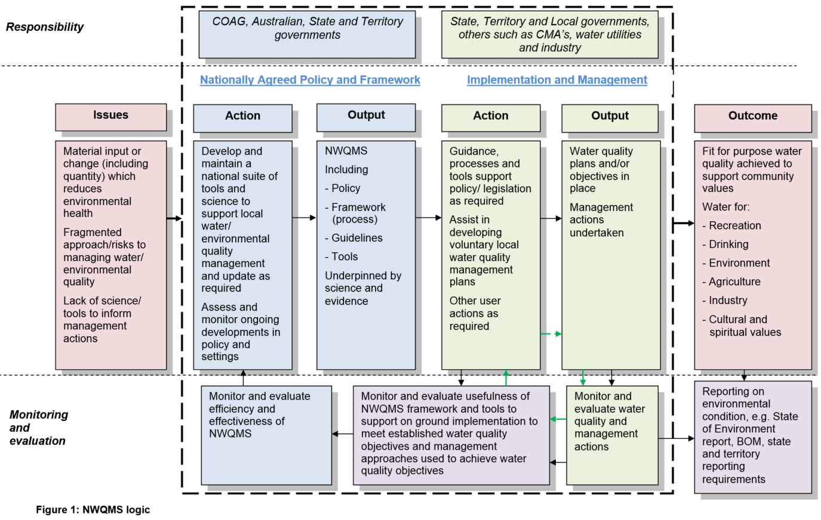

### Responsibility for the NWQMS

The Australian, state and territory governments work together on the nationally agreed policy and tools that will deliver water that is fit for purpose. Australian, state, territory and local governments, as well as other groups such as industry, utilise the NWQMS to manage water quality within their jurisdiction.

The Australian, state and territory governments support the NWQMS through developing and revising guidelines; developing a framework for assessing and managing water quality issues; and providing information applicable to numerous sources of water, from fresh water to marine water to recycled water. Governments work together to identify, develop and approve tools and information under the NWQMS or work with other agencies, organisations or bodies to develop or update guidelines. Intergovernmental committees are utilised to provide oversight and approval authority.

### Effectiveness of the NWQMS

The effectiveness of the NWQMS in meeting the objective will depend upon whether the NWQMS tools and resources are effective and utilised. Meeting the objective will also rely on implementation; hence, evaluating the effectiveness of actions to manage water quality is also included in the following questions for determining the effectiveness of the NWQMS:

* Did the NWQMS information, tools and arrangements assist water quality planning?
* Did implementation activities set water quality objectives?
* Were effective actions undertaken to manage water quality?

The NWQMS logic provides the basis for the evaluation framework. The Australian, state and territory governments will agree on performance indicators to enable monitoring of the NWQMS over time. These will be published in the [National Water Quality Management Strategy: Monitoring and evaluation plan](http://www.waterquality.gov.au/about/monitoring-evaluation-plan).

### NWQMS tools and information

The NWQMS contains tools and information to support water quality management. The tools include a Water Quality Management Framework for assessing and managing water quality issues and robust guidelines based upon best available science. The tools are a key component of understanding and improving water quality. More information about these tools is in the following sections.

The website also contains other information, such as fact sheets and case studies on key water quality issues and planning to achieve improved water quality.

### NWQMS Guidelines

Guidelines provide information tailored to meet the needs of water quality managers to obtain water quality that will be fit for purpose. There can be a range of guideline documents covering subjects such as water for drinking and the environment and managing water quality from human-induced processes such as industrial discharges and run-off from urban areas.

Guidelines may be added, revised or removed over time to address evolving conditions and needs.

To improve management of guidelines, four categories have been established:

* *Primary*—these are key documents for protecting human health and the environment and managing contentious and sensitive issues. These documents will be maintained and updated.
* *Secondary*—these are important documents for addressing gaps or emerging issues in water quality management, but they may not necessarily be maintained or updated once developed.
* *Reference documents*—these are not guidelines under the NWQMS, but they will be published on the NWQMS website, as they can provide useful information for water quality managers.
* *Retired documents*—these documents no longer provide useful information, are out of date and considered unhelpful as a reference document, are significantly deficient and possibly containing erroneous material, or superseded. They will be removed from the website.

Some of the primary guidelines for managing water quality include:

* The *Australian drinking water guidelines*
* The *Australian and New Zealand Guidelines for Fresh and Marine Water Quality*
* The *Guidelines for managing risks in recreational water.*

Some of the secondary guidelines include:

* *Rural land uses and water quality*
* *Guidelines for urban stormwater management*
* *Guideline for sewage systems—biosolids management*.

An organisation, industry body, government department or committee will generally have responsibility for maintaining or updating individual guidelines in the primary and secondary categories according to a review process established to suit each specific guideline.

New guidelines may be developed to address an issue or knowledge gap if they meet a number of principles, including the following:

* There is an issue or that gap requires nationally consistent intervention.
* National guidelines will help to harmonise the management of water resources, particularly cross-border and cross-catchment water bodies; reduce duplication; and contribute to achieving effective management and effective and efficient regulation.
* The guideline will address impacts on health, environmental, social, cultural and/or economic values.
* National guidelines will be designed to protect environment and/or human health or assist to manage risk for contentious, sensitive or emerging issues.

Guidelines can be developed by third parties, such as industry groups and local governments. New guidelines would need to meet certain criteria to be included under the NWQMS and these are outlined in [Design and requirements for a new guideline.](http://www.waterquality.gov.au/guidelines/new-design-requirements)

Guidelines may be revised as required—for example, if new information needs to be incorporated. The process for reviewing and/or updating guidelines will vary for each guideline and will ultimately be a decision for the body responsible for each individual guideline.

For governments and those who wish to develop a new guideline, more information about the processes and considerations for adding, reviewing and revising guidelines is available in the [Standard operating procedure for managing guidelines](http://www.waterquality.gov.au/about/standard-operating-procedures).

## Water Quality Management Framework

Figure 2 Water Quality Management Framework

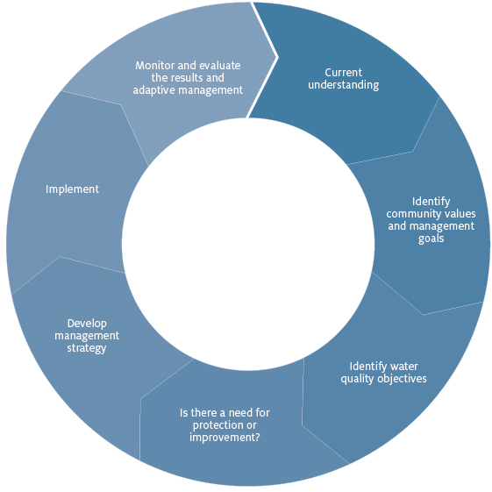

Note: A more detailed Water Quality Management Framework is in the [Australian and New Zealand Guidelines for Fresh and Marine Water Quality](http://www.waterquality.gov.au/anz-guidelines).

### About the Water Quality Management Framework

The Water Quality Management Framework is a process for understanding and managing water quality to achieve water that is fit for purpose. This key tool utilises the guidelines and other resources under the NWQMS to provide the information needed to manage water quality. The steps shown in Figure 2 assist water managers to identify the current issues, the desired water quality objectives, and actions to achieve these objectives. More information about each step is given in the following section.

## Key steps in the Water Quality Management Framework

### Current understanding

The first step is to document the current understanding of the catchment and waterways. This includes the key features of the water resource (such as whether it is fresh or marine, intermittent or permanent), the current water quality, the relationship between quality and water flows and what natural and human processes are occurring in the area. Understanding current management strategies assists to identify water quality issues and problems. It will also link closely with the next step to establish the key uses and values for the waters (community values).

Box 1 Pressure–Stressor–Response on Community Values model

|  |
| --- |
| Understanding the water resource will help identify what might be causing problems with the water quality. A concept known as Pressure–Stressor–Response on Community Values (CVs) can assist to link what is occurring in and around the water resource to the problems that have been observed. |

Figure 3 Examples of pressures, stressors and responses

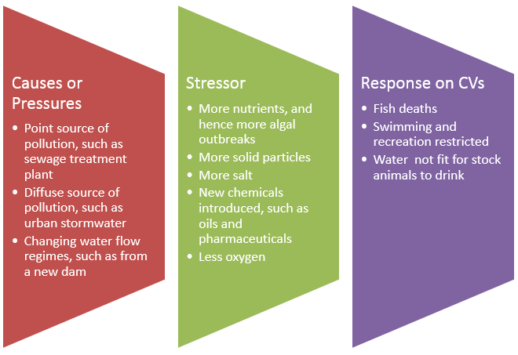

Information to document current understanding can come from numerous sources, including water quality monitoring, modelling programmes, expert advice, community input and previous studies. A [conceptual model/diagram](http://www.ozcoasts.gov.au/conceptual_mods/stressors/images/Nutrients_final.jpg) showing what is occurring in the water resource can assist in summarising and communicating all the above information.

### Identifying community values and management goals

This step focuses on identifying the community’s current uses and values and future expectations for the catchment and waterways. What will the water be used for and what are its values?

Key community values are:

* aquatic ecosystems
* cultural and spiritual values
* drinking water
* industrial water
* primary industries
* recreation and aesthetics.

These community values are defined in the Glossary. There is also more information about the values within guidelines designed to protect specific values, such as the *Australian Drinking water quality guidelines*.

It should also be recognised that water resources have important cultural and spiritual values, particularly for Indigenous peoples of Australia. A better understanding of Indigenous cultural and spiritual values as they relate to water is essential to inform discussions with Indigenous people. Principles that can provide a useful perspective and a starting point for discussion are at Attachment A: Indigenous cultural and spiritual values.

Stakeholder consultation assists in identifying and detailing values. The community, industry, government, Indigenous and other stakeholders can identify their key uses and values of the water resources. There will probably be more than one value, such as a healthy aquatic environment, water for irrigation and/or water that is safe for swimming.

It will be necessary to develop more specific goals that address important components of the community value, such as protecting an endangered fish species or the water quality that is suitable for particular crops. These will then become more specific management goals. These management goals, and technical water quality guideline values for relevant indicators, help set water quality objectives to be achieved and subsequently assess whether management actions are protecting the community values.

Box 2 Indicators

|  |
| --- |
| Indicators are things that can be measured that help explain what is occurring in and around the water resource, including the condition of the water (similar to the use of human health indicators such as blood pressure). They can be physical, chemical, biological or socio-economic (for example, the cost of operating water treatment facilities). Choosing representative indicators for pressures and stressors assists assessing whether management actions are achieving the desired water quality objectives.  For a management goal of protecting an endangered fish species, an indicator could be monitoring the number of that species over time. For a goal of water that is safe for swimming, regular and event-based testing of the water for a number of microbiological and chemical indicators, such as bacteria and pH, could be undertaken. Clear management goals and good indicators will make it easier to develop actions to improve the water resource and determine whether those actions work into the future. |

### Identifying water quality objectives

Water quality objectives are the locally specific guideline values for relevant indicators that will protect all the community values and management goals. These objectives can be numerical guideline values, a narrative statement and/or targets to be achieved over time. The guideline values are usually based on scientific or expert advice about what water quality is required to protect each community value or management goal.

For example, an endangered fish species may start to suffer if the amount of oxygen in the water drops too low or if there are toxic chemicals in the water above a certain amount. The levels or concentrations at which adverse effects may be felt by the fish are called guideline values. These alert water quality managers to when actions need to be taken.

Many guidelines under the NWQMS provide default guideline values for different community values. Methods for tailoring these to local circumstances can be found in the relevant NWQMS documents for different community values.

Water quality objectives can be adjusted to reflect social and economic considerations. For example, an initial management goal for a river may be to have water quality that is suitable for swimming. However, an evaluation of the proposed actions to achieve this goal may find that it is too expensive or difficult to address all of the issues (or pressures) causing the unsuitable water quality. The management goal could then be changed to one that ensures water is suitable for rowing or other non-contact uses or where swimming is permitted only at limited times of the year. These goals may have different guideline values; therefore, a new water quality objective could be put in place.

### Identify whether there is a need for improvement or maintenance

Comparing the current water quality with the water quality objectives or water quality targets will show if there is a need for improvement and where improvement may be required. Management actions will then need to be identified to enhance water quality. If the current water quality meets the water quality objectives, there may need to be actions to maintain the water quality into the future.

### Management strategy

There can be many different actions to minimise adverse impacts from the key causes of water quality problems. Some actions could be regulatory, such as governments setting licence conditions for sewage treatment plants’ discharges. Some actions may involve the community, such as planting trees along river corridors to minimise sediments going into the water. There is a wealth of information from the years of work on catchment management and effective practices (also referred to as best practice) in urban environment, agriculture and industry.

Management actions should also take into account the flow or watering regime. Hydrological modelling, water resource plans and other information that helps to characterise the quality/quantity relationship can assist integrating water quality and water quantity in a management strategy.

All of the possible actions should be developed, assessed and prioritised. This results in a management strategy to address the key problems. Once management options have been developed, the actions may need to be modelled and costed to establish whether they will be technically sound and economically feasible, and consultation may need to establish whether they will be socially acceptable. If the actions are not feasible then there could be a number of options.

A key option is to set intermediate management goals and hence water quality objectives that will be feasible and will improve water quality towards the desired objective. This could mean setting a management goal to maintain the current water quality in the short term towards a long-term (or aspirational) goal of improving the water quality.

### Implement the strategies

Once management actions have been prioritised and agreed then implementation can go ahead. It can be useful to develop partnerships or agreements with those who will be funding and/or undertaking the actions. One example is using a Water Quality Improvement Plan process, where different parties agree on the water quality objectives and agree to undertake the actions to improve water quality. Parties could include governments, organisations and landholders.

Implementation may take a number of years to complete, and actions may need to be prioritised—for example, those that are urgent and have funding available may be prioritised.

### Monitoring and evaluation

Once implementation of management strategies has commenced, a monitoring programme should be undertaken to find out if these strategies are achieving the desired water quality (noting that there may be a time lag between action and outcomes). The monitoring programme should use the relevant water quality indicators based on the water quality objectives that will protect desired community values and management goals. The improvements in management actions must also be monitored.

It is important to evaluate the monitoring results, as the actions may not be achieving the desired outcomes or circumstances may have changed. New or modified actions may need to be incorporated into the management strategy or the management goals (and hence water quality objectives) may need to be re-examined and even further changed. Learning from the actions and monitoring is the key to adaptive management and achieving the water quality objectives.

## More information

The [NWQMS website](http://www.waterquality.gov.au/) has a range of guidelines and other information that can assist water quality management. Alternatively, telephone the Department of Agriculture and Water Resources on 1800 900 090.

Other sources of information can be found on state, territory and local government websites or from catchment management authorities, industry and agricultural groups. Research institutes or universities may also have relevant information.

## Attachment A: Indigenous cultural and spiritual values

### Introduction

A number of the guidelines contained within the NWQMS have been developed collaboratively or have been agreed to by both the Australian and New Zealand governments.

Water resources have important cultural and spiritual values, particularly for Indigenous peoples of Australia and New Zealand. Indigenous peoples also believe that the land, sky, water, and its people are inseparable—they are all connected. In order to achieve the best outcomes for the preservation and enhancement of cultural and spiritual values, water quality planning must be integrated or linked with water allocation (quantity) planning and management processes, as they are intrinsically linked.

### Incorporating Indigenous cultural and spiritual values in water quality planning

Figure 4 illustrates steps for incorporating Indigenous cultural and spiritual values into water quality planning. The steps are as follows:

* Engage with Indigenous people and discussion of cultural and spiritual values.
* Test whether those values can be supported using existing guidelines.
* Develop water quality objectives and management response options.
* Discuss the response options with Indigenous people.
* Incorporate the values into water quality.
* Implement and monitor the water quality management plan.

For a fuller explanation of the steps, please visit the [NWQMS website](http://www.waterquality.gov.au/guideline-values/derive/cultural-values).

Figure 4 Steps for incorporating cultural and spiritual values into water quality planning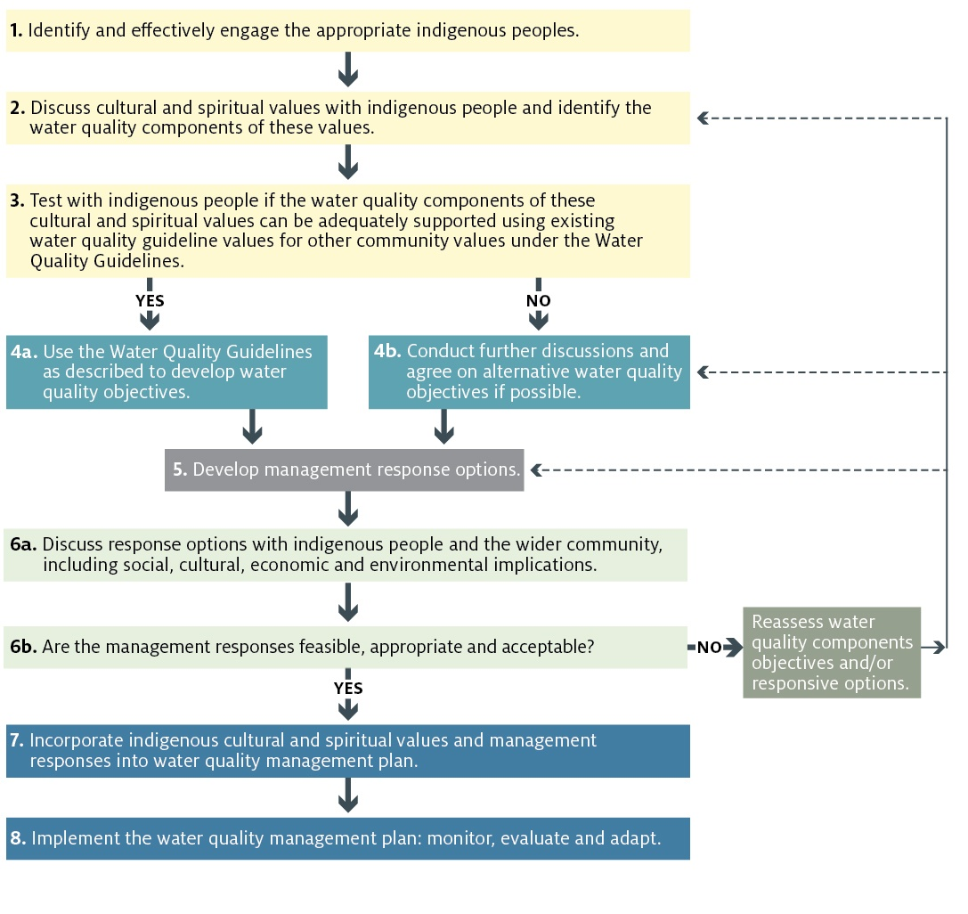

### Further information

More information about incorporating cultural and spiritual values into water quality management is provided on the [NWQMS website](http://www.waterquality.gov.au/guideline-values/derive/cultural-values).

## References

Bennett, J 2008, Final Discussion Paper on Implementation of the National Water Quality Management Strategy, Department of the Environment, Water, Heritage and the Arts, Canberra.

KPMG 2011, [Evaluation of the National Water Quality Management Strategy](http://www.environment.gov.au/resource/independent-evaluation-national-water-quality-management-strategy), Department of Sustainability, Environment, Water, Population and Communities, Canberra.