# Toxicant default guideline values for aquatic ecosystem protection

Simazine in freshwater

Technical brief

July 2024

© Commonwealth of Australia 2024

**Ownership of intellectual property rights**

Unless otherwise noted, copyright (and any other intellectual property rights, if any) in this publication is owned by the Commonwealth of Australia (referred to as the Commonwealth).

**Creative Commons licence**

All material in this publication is licensed under a Creative Commons Attribution 4.0 Australia Licence, save for content supplied by third parties, photographic images, logos and the Commonwealth Coat of Arms.

by

Creative Commons Attribution 4.0 Australia Licence is a standard form licence agreement that allows you to copy, distribute, transmit and adapt this publication provided you attribute the work. See the [summary of the licence terms](https://creativecommons.org/licenses/by/4.0/) or the [full licence terms](https://creativecommons.org/licenses/by/4.0/legalcode).

Inquiries about the licence and any use of this document should be emailed to [copyright@dcceew.gov.au](mailto:copyright@dcceew.gov.au).

**Cataloguing data**

This publication (and any material sourced from it) should be attributed as: ANZG 2024, *Toxicant default guideline values for aquatic ecosystem protection: Simazine in fresh water.* Australian and New Zealand Guidelines for Fresh and Marine Water Quality. CC BY 4.0. Australian and New Zealand Governments and Australian state and territory governments, Canberra, ACT, Australia.

This publication is available at [waterquality.gov.au/anz-guidelines/guideline-values/default/water-quality-toxicants/toxicants](http://www.waterquality.gov.au/anz-guidelines/guideline-values/default/water-quality-toxicants/toxicants).

**Contact**

Australian Government Department of Climate Change, Energy, the Environment and Water

GPO Box 3090 Canberra ACT 2601

General enquiries: 1800 920 528

Email [waterquality@dcceew.gov.au](mailto:waterquality@dcceew.gov.au)

**Disclaimer**

The author(s) of this publication, all other entities associated with funding this publication or preparing and compiling this publication, and the publisher of this publication, and their employees and advisers, disclaim all liability, including liability for negligence and for any loss, damage, injury, expense or cost incurred by any person as a result of accessing, using or relying on any of the information or data in this publication to the maximum extent permitted by law.

**Acknowledgements**

The default guideline values were derived by Olivia C King and Dr Rachael A Smith (Water Quality and Investigations, Environmental Monitoring and Assessment Sciences, Science & Technology, Queensland Department of Environment and Science, DES), Gabrielle Dern (Griffith University) and Dr Michael St J Warne (School of Earth and Environmental Sciences, University of Queensland; DES). The DGVs were peer reviewed by two anonymous reviewers, Dr Reinier Mann (DES) and by a contracted technical advisor, Dr Rick van Dam. The DGVs were also reviewed and approved by jurisdictional technical and policy oversight groups and a National Water Reform Committee, prior to being published.



Contents

Summary v

1. Introduction 1

2. Aquatic toxicology 2

2.1. Mechanisms of toxicity 2

2.2. Relative toxicity 3

3. Factors affecting toxicity 3

4. Default guideline value derivation 4

4.1. Toxicity data used in derivation 4

4.2. Species sensitivity distribution 6

4.3. Default guideline values 7

4.4. Reliability classification 8

Glossary, Acronyms and Abbreviations 9

Attachment A: Summary details of the toxicity data used to derive default guideline values for simazine in freshwaters 12

Attachment B: Modality assessment for simazine toxicity to aquatic species 17

References 21

Figures

Figure 1. Structure of simazine 1

Figure 2. Species sensitivity distribution for simazine in freshwater 7

Figure 3. Box plot of the log-transformed ecotoxicity data for freshwater and marine species exposed to simazine 18

Figure 4. Histogram of the log-transformed ecotoxicity data for fresh and marine species exposed to simazine 18

Figure 5. Box and whisker plots of available ecotoxicity data for the different types of fresh and marine organisms exposed to simazine. 19

Figure 6. Species sensitivity distribution, generated by Burrlioz 2.0, using available ecotoxicity data for the different types of fresh and marine organisms exposed to simazine 19

Tables

Table 1. Summary of selected physicochemical properties of simazine 1

Table 2. Summary of the single toxicity values for each phototrophic species that was used to derive the default guideline values for simazine in freshwaters. Data are arranged in alphabetical order of the test species 5

Table 3. Default guideline values (µg/L) for simazine for the protection of freshwater ecosystems. 8

## Summary

Simazine (IUPAC name: 6-chloro-N2,N4-diethyl-1,3,5-triazine-2,4-diamine; CAS No. 122-34-9) is a selective, systemic triazine herbicide, or more specifically a chlorotriazine herbicide. Other chlorotriazine herbicides include atrazine, propazine and terbuthylazine. Simazine is a common photosynthesis-inhibiting herbicide used to control a large variety of weed species in agriculture (for specific cropping and non-cropping purposes), forestry and a range of urban and industrial settings (ACVM 2020, APVMA 2020, Growcom Australia Pty Ltd 2020).

The previous Australian and New Zealand default guideline value (DGV) for simazine in freshwater environments was a moderate reliability (using the ANZECC and ARMCANZ 2000 reliability scheme) value, as it was based on a mixture of chronic and acute toxicity data for 12 species from four taxonomic groups (i.e. fish, crustaceans, insects and algae) (Warne 2001). More data on simazine toxicity to freshwater species are now available, including data to phototrophic species (species that photosynthesise e.g. plants and algae) that enable the calculation of more reliable DGVs.

While simazine does have a specific mode of action (inhibition of the photosystem II pathway), it also has a non-specific mode of action (formation of reactive oxygen species, ROS) and can exert biochemical effects such as endocrine disruption in non-target organisms. Generally, endocrine disrupting effects are not considered in the derivation of DGVs. The above information indicates that simazine should be more toxic to phototrophic species than to heterotrophic species. Overall, the various lines of evidence (Attachment B) indicate no difference in the sensitivity of phototrophic and heterotrophic species; therefore, the DGVs were derived using toxicity data for both of these groups of organisms. The lowest reported chronic toxicity value to freshwater species is 32 µg/L (freshwater microalga, 3-day NOEC) and the lowest reported acute toxicity value to freshwater species is 0.65 µg/L (freshwater microalga, 1-day NOEC).

Very high reliability DGVs for simazine in freshwaters were derived based on chronic no observed effect concentration (NOEC), no observed adverse effect concentration (NOAEC) and chronic estimated NOEC data (chronic EC50 data converted to chronic estimated NOEC values) for 20 freshwater phototrophic and heterotrophic species from four phyla and six classes, and a good fit of the species sensitivity distribution (SSD) to the toxicity data. It should be noted that the DGVs derived here are expressed in terms of the active ingredient (simazine) rather than commercial formulations. The DGVs for 99, 95, 90 and 80% species protection are 6.1 µg/L, 12 µg/L, 18 µg/L and 29 µg/L, respectively. The 95%species protection level for simazine of 12 µg/L is recommended for adoption in the assessment of slightly to moderately disturbed ecosystems.

## Introduction

Simazine is a triazine herbicide (C7H12ClN5; see Figure 1) present as a white powder at room temperature. It is the active ingredient of a variety of commercial herbicide formulations. In Australia, the majority of commercial formulations of simazine do not contain any other herbicides; however, simazine may be mixed with other herbicides in on-farm tank mixes in order to increase its efficacy. Physicochemical properties of simazine that may affect its environmental fate and toxicity are presented in Table 1.

Figure 1. Structure of simazine

Table 1. Summary of selected physicochemical properties of simazine

|  |  |  |
| --- | --- | --- |
| **Physicochemical property** | **Value** | |
| Molecular weight | | 201.7 amu1 |
| Aqueous solubility | | 6.2 mg/L @ pH 7 and temperature of 22 oC1 5 mg/L @ temperature of 20 oC2 |
| Logarithm of the octanol-water partition coefficient (log Kow) | | 2.11 2.3 @ pH 7 and temperature 20 oC2 |
| Logarithm of the organic carbon water partition coefficient (log Koc) | | 2.201 2.14 @ temperature 25 oC2 |
| Logarithm of the bioconcentration factor (log BCF) | | 2.342 <2.03 |
| Half-life in water (t1/2) | | Freshwater: 8.8 days (pH 1), 96 days (pH 5), 3.7 days (pH 13)1 Marine: 579 ± 294 days (dark, at temperature 25 ºC) 96 days @ pH 7 and temperature 20 oC2 |
| Half-life in soils (t1/2) | | 90 days (field)2 Typical: 60 days2 |

1 BCPC (2012). 2 Pesticide Properties Database (University of Hertfordshire 2013). 3 CCME (1999). 4 Mercurio et al. (2015).

Simazine belongs to the chlorotriazine group within the triazine family of herbicides, which also includes atrazine, propazine and terbuthylazine. It is used as both a knockdown and residual herbicide and it can retain its biological effectiveness in soil for a year after application. Simazine is generally applied before weeds emerge (i.e. it is a pre-emergent herbicide). In Australia and New Zealand, simazine is approved for weed control purposes in agriculture (e.g. apples, asparagus, berry fruits, broad beans, chick peas, citrus, grapes, lucerne, pears and wheat), forestry and a range of urban and industrial uses (e.g. weed control around buildings, drains, roadsides, footpaths and other commercial and public land) (ACVM 2020, APVMA 2020, Growcom Australia Pty Ltd 2020).

Simazine has poor to moderate soil binding characteristics due to its low log Koc value (Table 1). Although it has a low aqueous solubility, it has a long half-life in aquatic environments (Table 1) and is frequently detected in surface and ground waters throughout Europe (Oropesa et al. 2009b and references therein), Northern America (Stone et al. 2014) and Eastern Australia (e.g. Allinson et al. 2015; Devlin et al. 2015; Wallace et al. 2015, 2016; Vandergragt et al. 2020; Warne et al. 2020). Due to its widespread detection at elevated concentrations and its broad range of adverse effects, simazine has been included in the EU Priority Pollutants List and the equivalent USEPA list (Stara et al. 2012).

## Aquatic toxicology

## **Mechanisms of toxicity**

Simazine is mainly absorbed through the roots of plants and transported to the leaves, where it exerts its toxicity. Simazine exerts its toxicity in aquatic plants (including aquatic macrophytes and algae) by inhibiting electron transport in the photosystem II (PSII) complex (University of Hertfordshire 2013), a key process in photosynthesis that occurs in the thylakoid membranes of chloroplasts. Photosynthesis inhibiting herbicides bind to the plastoquinone B (QB) protein binding site on the D1 protein in PSII. This prevents the transport of electrons to synthesise adenosine triphosphate (ATP, used for cellular metabolism) and nicotinamide adenine dinucleotide phosphate (NADPH, used in converting CO2 to glucose), and therefore, prevents CO2 fixation (Wilson et al. 2000).

In addition to its main mode of action, exposure to PSII inhibiting herbicides can lead to marked increases in the formation or transient accumulation of reactive oxygen species (ROS), including singlet oxygen (1O2), superoxide (O2-) and hydrogen peroxide (H2O2) (Halliwell 1991, Ramel et al. 2009). Reactive oxygen species are highly reactive forms of oxygen that readily react with, and bind to, biomolecules including deoxyribonucleic acid (DNA) and ribonucleic acid (RNA). Reactive oxygen species are created during normal cellular functioning particularly in biochemical processes that involve the generation of energy (e.g. photosynthesis in chloroplasts and the Krebs cycle in the mitochondria of cells). In phototrophs, ROS are formed when the absorbed light energy exceeds the ability to convert CO2 to organic molecules, thus accumulating oxygen (Chen et al. 2012). Normal concentrations of ROS are involved in a number of cellular processes (Chen et al. 2012). However, prolonged exposure to elevated concentrations of ROS in plants, as a result of biotic (e.g. disease) and/or abiotic stressors (e.g. PSII inhibiting herbicides), can cause irreversible cell damage and ultimately lead to cell death (apoptosis).

While simazine predominantly targets the PSII complex it can also exert biochemical effects in other non-target organisms. It is also known to cause endocrine disrupting effects (Depledge and Billinghurst 1999, Mnif et al. 2011, United Nations Environment Programme and the World Health Organization, 2013); for example, concentrations of 1 to 2 µg/L can lead to inhibition of the endocrine mediated olfactory response of male Atlantic salmon (*Salmo salar* L.) to the female priming pheromone, prostaglandin (Moore and Lower 2001).

## **Relative toxicity**

There were toxicity data for 29 freshwater species that passed the screening and quality assessment processes. These consisted of 17 freshwater phototrophic species and 12 heterotrophic species. The phototrophic species consisted of eight green algae, seven macrophytes, a single diatom and a single blue-green alga. The heterotrophs consisted of five fish, five crustaceans and two insects.

Generally, phototrophic species appear to be more sensitive than heterotrophic species, although there is considerable overlap in in sensitivity between the two groups, with 13 of the 15 heterotrophs having toxicity values within the range of phototroph values. Based on multiple lines of evidence (Attachment B), it was difficult to conclude that there is a difference in the sensitivity of phototrophic species and heterotrophic species.

The ten species of freshwater algae for which there are simazine toxicity data range in sensitivity between 0.65 µg/L for *Scenedesmus acutus* (based on an acute NOEC; Faust et al. 2001) to 56,900 µg/L for *Scenedesmus vacuolatus* (based on an acute EC50; Faust et al. 2001). The least sensitive algal species, *S. vacuolatus*, was approximately 40-times less sensitive than the next least sensitive alga (*Scenedesmus obliquous*, chronic IC50 of 1498 µg/L; Chan 2005). The seven species of macrophytes had a similar albeit narrower range of sensitivity compared to the algal species, of between 50 µg/L for *Myriophyllum aquaticum* (based on a 7-day chronic LOEC; Knuteson et al. 2002) to 1000 µg/L for *Typha latifolia* (based on a chronic 7-day LOEC; Wilson et al. 2000). Toxicity data for eight macroinvertebrates indicated they were generally less sensitive than phototrophic species to simazine, ranging from 1100 µg/L for *Daphnia magna* (based on an acute 4-day EC50; USEPA 2015b) to 100,000 µg/L for *Procambarus* *sp.* (both based on acute 2-day LC50; USEPA 2015b). The fish data were also generally less sensitive than phototrophic species, ranging from 45 µg/L for *Cyprinus carpio* (based on a chronic 90-day NOEC; Oropesa et al. 2009) to 51,000 µg/L for *Pimephales promelas* (based on an acute 4-day LC50; USEPA 2015b).

## Factors affecting toxicity

As with many organic chemicals, it might be expected that dissolved and particulate organic matter and suspended solids would affect its bioavailability and toxicity. However, any such effect would be relatively minor given the relatively low log Koc value of simazine. As noted in section 2.1, one of the modes of action of simazine is to increase the formation of ROS. Given that the formation of ROS is dependent on the presence of light, it is plausible that increased turbidity (e.g. from increased suspended solids) could lead to a decrease in simazine toxicity. However, the information on this potential toxicity modifying factor for PSII herbicides is contradictory. A major review by Knauer et al. (2016) concluded that the presence of suspended solids did not significantly decrease toxicity of a range of pesticides including atrazine (a PSII herbicide, like simazine) to freshwater species. In contrast, Wilkinson et al. (2017) found that decreased light intensity had a significant antagonistic effect on diuron (another PSII herbicide) toxicity to the seagrass *Halophila ovalis*. There appear to be no such data for simazine.

## Default guideline value derivation

The DGVs were derived in accordance with the method described in Warne et al. (2018) and using Burrlioz 2.0 software.

## **Toxicity data used in derivation**

To obtain toxicity data for simazine to freshwater organisms, an extensive search of the scientific literature was conducted. In addition, the databases of the USEPA ECOTOX (USEPA 2015a), Office of the Pesticide Program (USEPA 2015b), the Australasian Ecotoxicology Database (Warne et al. 1998) and the ANZECC and ARMCANZ (2000) toxicant databases (Sunderam et al. 2000) were searched. There are now more simazine toxicity data available that enable the calculation of DGVs in freshwaters (Attachment A). All the toxicity data used to calculate the DGVs were determined from experiments using technical or higher grades of simazine with a minimum purity of 80% active ingredient (Warne et al. 2018).

In total, there were toxicity data for 29 freshwater species (17 phototrophic species and 12 heterotrophic species representing six phyla and 10 classes) that passed the screening and quality assessment processes. The represented phyla were Arthropoda, Chlorophyta, Chordata, Cyanobacteria, Bacillariophyta and Tracheophyta. The 10 classes were Actinopterygii (which accounts for approximately 99% of fish), Bacillariophyceae (a major grouping of diatoms), Branchiopoda (a grouping of crustaceans), Chlorophyceae (a major grouping of freshwater green algae), Cyanophyceae (a class of cyanobacteria), Insecta (invertebrates), Liliopsida (monocots), Magnoliopsida (dicots), Malacostraca (a large grouping of crustaceans) and Trebouxiophyceae (another grouping of green algae). Chronic toxicity data were available for 20 of the 29 species, comprising 14 phototrophs and six heterotrophs, while acute toxicity data only were available for nine species, comprising three phototrophs and six heterotrophs.

As noted in section 2, the specific mode of action of simazine on plant photosynthesis indicates that phototrophic species would be more sensitive than non-phototrophic species. However, simazine and other PSII-inhibiting herbicides also exert toxicity by increasing the synthesis of reactive oxygen species (ROS) and can exert endocrine disrupting effects. A modality assessment of the simazine toxicity data (to both marine and freshwater species) was undertaken according to the weight of evidence approach described by Warne et al. (2018). The majority of the lines of evidence supported the conclusion that the dataset was unimodal, with no clear difference in the sensitivity of phototrophic and heterotrophic species (Attachment B). Therefore, as recommended by Warne et al. (2018), toxicity data for all available organisms were used to calculate the DGVs.

There were freshwater chronic negligible effect (i.e. NOEC, NOAEC) data for only six species that belonged to three phyla. This did not meet the minimum data requirements to use a species sensitivity distribution (SSD) method (i.e. at least five species belonging to at least four phyla, Warne et al. 2018). Therefore, the dataset was expanded to include chronic LOEC and EC50 data that were then converted to estimates of chronic negligible effect data (i.e. chronic LOEC and EC50 toxicity data converted to estimates of chronic negligible effect data by dividing by 2.5 and 5, respectively). This resulted in a dataset with toxicity data for 20 freshwater phototrophic and heterotrophic species that belonged to six phyla and eight classes, which met the minimum data requirements to derive DGVs using a SSD. The final dataset included six NOECs (including one NOAEC), five (converted) LOECs and nine (converted) EC50s. A summary of the toxicity data (one value per species) used to calculate the DGVs for simazine in freshwater environments is provided in Table 2, while additional details of the data are provided in Attachment A. Details of the data quality assessment and the data that passed the quality assessment are provided as supporting information.

Table 2. Summary of the single toxicity values for each phototrophic species that was used to derive the default guideline values for simazine in freshwaters. Data are arranged in alphabetical order of the test species

|  |  |  |  |  |  |  |
| --- | --- | --- | --- | --- | --- | --- |
| **Taxonomic group** | **Species** | **Life stage** | **Duration (days)** | **Toxicity measure (endpoint)** | **Toxicity value  (µg/L)** | **Final toxicity values (µg/L)** |
| Macrophyte (Tracheophyta) | *Acorus gramineus* | Not stated | 7 | Chronic NOEC (Fresh weight) | 100 | 100 |
| Blue-green alga (Cyanobacteria) | *Anabaena flosaquae* | Not stated | 5 | Chronic EC50 (Cell density) | 36 | 7.2a |
| Goldfish (Chordata) | *Carassius auratus* | Not stated | 365 | Chronic LOEC (Mortality) | 2,500 | 1,000a |
| Green alga (Chlorophyta) | *Chlamydomonas geitleri* | Exponential growth phase | 3 | Chronic EC50 (Chlorophyll-a content) | 855.5b | 171 a |
| Green alga (Chlorophyta) | *Chlorella pyrenoidosa* c | Not stated | 6 | Chronic EC50 (Abundance) | 1,301 | 260a |
| Green alga (Chlorophyta) | *Chlorella vulgaris* c | Not stated | 4 | Chronic EC50 (Growth rate) | 422 b | 84.4a |
| Common Carp (Chordata) | *Cyprinus carpio* | Not stated | 90 | Chronic NOEC (Weight/mortality) | 45b | 45 |
| Cladoceran (Arthropoda) | *Daphnia magna* | Not stated | 21 | Chronic LOEC (Mortality) | 2,500b | 1,000a |
| Macrophyte (Tracheophyta) | *Lemna gibba* | Not stated | 14 | Chronic EC50 (Biomass yield) | 140b | 28a |
| Bluegill (Chordata) | *Lepomis macrochirus* | Not stated | 365 | Chronic LOEC (Mortality) | 2,500b | 1,000a |
| Macrophyte (Tracheophyta) | *Myriophyllum aquaticum* c | 2 weeks old | 7 | Chronic LOEC (Fresh weight) | 50b | 20a |
| Diatom (Bacillariophyta) | *Navicula pelliculosa* c | Not stated | 5 | Chronic EC50 (Cell density) | 90b | 18a |
| Rainbow trout (Chordata) | *Oncorhynchus mykiss* c | Not stated | 28 | Chronic EC50 (Mortality) | 2,500b | 500a |
| Fathead minnow (Chordata) | *Pimephales promelas* | Early life stage | 120 | Chronic LOEC (Mortality) | 2,500b | 1,000a |
| Macrophyte (Tracheophyta) | *Pontederia cordata* | Not stated | 7 | Chronic NOEC (Fresh weight) | 100 | 100 |
| Green alga (Chlorophyta) | *Pseudokirchneriella subcapitatad* | Not stated | 3 | Chronic NOEC (Growth rate) | 32 | 32 |
| Green alga (Chlorophyta) | *Scenedesmus obliquus* c | Exponential growth phase | 4–6 | Chronic EC50 (Growth rate) | 257b | 51.4a |
| Green alga (Chlorophyta) | *Scenedesmus quadricauda* | Not stated | 4 | Chronic EC50 (Abundance) | 150b | 30a |
| Macrophyte (Tracheophyta) | *Typha latifolia* c | Not stated | 7 | Chronic NOEC  (Fresh weight) | 300 | 300 |
| Macrophyte (Tracheophyta) | *Vallisneria americana* | Not stated | 13 | Chronic NOAEC  (Fresh weight and length) | 58 | 58 |

a Chronic LOEC and EC50/IC50 values that were converted to chronic NOEC values by dividing by 2.5 and 5, respectively (Warne et al. 2018).

b Geometric mean.

c Species that originated from or whose geographic distributions include Australia and/or New Zealand.

d This species has also been called *Raphidocelis subcapitata* and *Selenastrum caprincornutum.*

To identify species that were regionally relevant to Australia and New Zealand ecosystems, a search of Algaebase (Guiry and Guiry 2017), Atlas of Living Australia (ALA 2017), Catalogue of Life (Roskov et al. 2017), Integrated Taxonomic Information System (ITIS 2017) and the World Register of Marine Species (WoRMS 2017) was conducted. The dataset used in the guideline derivation process for simazine in freshwaters (Table 2) includes toxicity data for seven freshwater species that either originated from or are distributed within Australia and/or New Zealand.

## **Species sensitivity distribution**

The cumulative frequency (species sensitivity) distribution (SSD) of the 20 freshwater phototrophic and heterotrophic species that was used to derive the DGVs is presented in Figure 2. The SSD was plotted using the Burrlioz 2.0 software. Notwithstanding the stacking of four toxicity values at the top of the SSD, the model was judged to provide a good fit to the data based on the good fit for the lower half of the SSD (Figure 2).

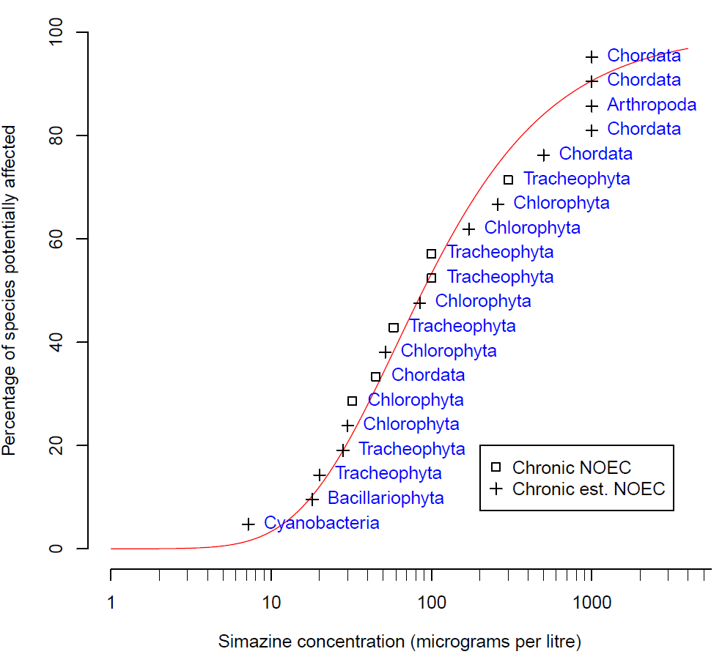

Figure 2. Species sensitivity distribution for simazine in freshwater

## **Default guideline values**

The DGVs for simazine in freshwaters are provided in Table 3. The 95% species protection DGV of 12 µg/L is recommended for application for slightly to moderate disturbed ecosystems. As with all the other pesticides, the DGVs for simazine are expressed in terms of the concentration of the active ingredient. Although some of the simazine toxicity data used to derive the DGVs may have incorporated toxicity due to simazine metabolites, this has not been quantified and, therefore, only simazine (and not any of its metabolites) should be measured for comparison with the DGVs.

Measured log BCF values for simazine are low (Table 1) and below the threshold at which secondary poisoning must be considered (i.e. threshold log BCF = 4, Warne et al. 2018). Therefore, the DGVs for simazine do not need to account for secondary poisoning.

Table 3. Default guideline values (µg/L) for simazine for the protection of freshwater ecosystems.

|  |  |
| --- | --- |
| **Level of species protection (%)** | **DGV for simazine in freshwater (µg/L) a** |
| 99 | 6.1 |
| 95 | 12 |
| 90 | 18 |
| 80 | 29 |

a Default guideline values were derived using the Burrlioz 2.0 (2016) software and rounded to two significant figures.

## **Reliability classification**

The simazine freshwater DGVs have a very high reliability classification (Warne et al. 2018) based on the outcomes for the following three criteria:

* Sample size—twenty (preferred)
* Type of toxicity data—chronic freshwater data
* SSD model fit—good (Burr type III).

## Glossary, Acronyms and Abbreviations

|  |  |
| --- | --- |
| **Acute toxicity** | An adverse effect that occurs as the result of a short-term exposure to a chemical relative to the organism’s life span. Refer to Warne et al. (2018) for examples of acute exposures. |
| **ANZECC** | Australian and New Zealand Environment and Conservation Council. |
| **ARMCANZ** | Agricultural and Resource Management Council of Australia and New Zealand. |
| **Bimodal** | When the distribution of the sensitivity of species to a toxicant has two modes. This typically occurs with chemicals with specific modes of action. For example, herbicides are designed to affect plants at low concentrations but most animals are only affected at high concentrations. |
| **CAS no.** | Chemical Abstracts Service number. Each chemical has a unique identifying number that is allocated to it by the American Chemical Society. |
| **Chronic toxicity** | An adverse effect that occurs as the result of exposure to a chemical for a substantial portion of the organism’s life span or an adverse sub-lethal effect on a sensitive early life stage. Refer to Warne et al. (2018) for examples of chronic exposures. |
| **Default guideline value (Default GV)** | A guideline value recommended for generic application in the absence of a more specific guideline value (e.g. site-specific), in the Australian and New Zealand Water Quality Guidelines. |
| **ECx** | The concentration of a chemical in water that is estimated to produce a x% effect on a sub-lethal endpoint. The magnitude of x can vary from 1 to 100, however values between 5 and 50 are more typical. The ECx is usually expressed as a time-dependent value (e.g. 24-hour or 96-hour ECx). |
| **EC50(Median effective concentration)** | The concentration of a chemical in water that is estimated to produce a 50% effect on a sub-lethal endpoint. The EC50 is usually expressed as a time-dependent value (e.g. 24-hour or 96-hour EC50). |
| **Endpoint** | A measurable biological effect including, but not limited to, lethality, immobility, growth inhibition, immunological responses, organ effects, developmental and reproductive effects, behavioural effects, biochemical changes, genotoxicity, etc. |
| **Guideline value (GV)** | A measurable quantity (e.g. concentration) or condition of an indicator for a specific environmental value below which (or above which, in the case of stressors such as pH, dissolved oxygen and many biodiversity responses) there is considered to be a low risk of unacceptable effects occurring to that environmental value. Guideline values for more than one indicator should be used simultaneously in a multiple lines of evidence approach. |
| **ICx** | The concentration of a chemical in water that is estimated to produce a x% inhibition of a sub-lethal endpoint (usually growth in phototrophic test organisms). The magnitude of x can vary from 1 to 100; however, values between 5 and 50 are more typical. The ICx is usually expressed as a time-dependent value (e.g. 24-hour or 72-hour ICx). |
| **LC50 (Median lethal concentration)** | The concentration of a chemical in water that is estimated to kill 50% of the test organisms. The LC50 is usually expressed as a time-dependent value (e.g. 24-hour or 96-hour LC50). |
| **LOEC** **(Lowest observed effect concentration)** | The lowest concentration of a chemical used in a toxicity test that has a statistically significant (p≤0.05) adverse effect on the exposed population of test organisms compared to the controls. All higher concentrations should also cause statistically significant effects. |
| **LOEL (Lowest observed effect level)** | Synonymous with LOEC. |
| **Mode of action** | The means by which a chemical exerts its toxic effects. For example, triazine herbicides inhibit the photosystem II component of plants photosynthesis biochemical reaction. |
| **NEC (no effect concentration)** | The highest concentration that does not have an effect – this is determined differently from a NOEC. |
| **NOEC** **(No observed effect concentration)** | The highest concentration of a toxicant used in a toxicity test that does not have a statistically significant (p>0.05) effect compared to the controls. The statistical significance is measured at the 95% confidence level. |
| **NOEL (No observed effect level)** | Synonymous with NOEC. |
| **Phototrophs** | Organisms that photosynthesize as their main means of obtaining energy e.g. plants and algae. |
| **PSII** | Photosystem II of the photosynthetic biochemical pathway. |
| **Site-specific** | Relating to something that is confined to, or valid for, a particular place. Site-specific trigger values are relevant to the location or conditions that are the focus of a given assessment. |
| **Species** | A group of organisms that resemble each other to a greater degree than members of other groups and that form a reproductively isolated group that will not produce viable offspring if bred with members of another group. |
| **SSD** | Species sensitivity distribution. A method that plots the cumulative frequency of species sensitivity and fits the best possible statistical distribution to the data. From the distribution the concentration that should theoretically protect a selected percentage of species can be determined. |
| **Toxicity** | The inherent potential or capacity of a material to cause adverse effects in a living organism. |
| **Toxicity test** | The means by which the toxicity of a chemical or other test material is determined. A toxicity test is used to measure the degree of response produced by exposure to a concentration of chemical. |

## Attachment A: Summary details of the toxicity data used to derive default guideline values for simazine in freshwaters

|  |  |  |  |  |  |  |  |  |  |  |  |
| --- | --- | --- | --- | --- | --- | --- | --- | --- | --- | --- | --- |
| Phyla/Division | Class | Species | Life stage | Exposure duration (days) | Test type | Toxicity measure (test endpoint) | Test medium | Temp. (°C) | pH | Concentration (µg/L) | Reference |
| Arthropoda | Branchiopoda | Water flea (*Daphnia magna*) | Not stated | 21 | Chronic | LOEC (Mortality) | Surface or ground, reconstituted or dechlorinated tap water | 20 ± 1 | Not stated | 2,500 | USEPA (2015) |
|  |  |  |  |  |  |  |  |  |  | **1,000@** | **VALUE USED IN SSD** |
| Bacillariophyta | Bacillariophyceae | Freshwater Diatom (*Navicula pelliculosa*) | Not stated | 5 | Chronic | EC50  (Cell density) | Algal nutrient medium | 20 - 24 ± 2 | Not stated | 90 | USEPA (2015) |
|  |  |  |  |  |  |  |  |  |  | **18**@ | **VALUE USED IN SSD** |
| Chlorophyta | Chlorophyceae | Microalga (*Chlamydomonas geitleri*) | Exponential growth phase | 3 | Chronic | EC50  (Growth rate) | Freshwater | 23 | 7.8 | 1,032 | Francois and Robinson (1990) |
| Chlorophyta | Chlorophyceae | Microalga (*Chlamydomonas geitleri*) | Exponential growth phase | 3 | Chronic | EC50  (Growth rate) | Freshwater | 23 | 7.8 | 812 | Francois and Robinson (1990) |
| Chlorophyta | Chlorophyceae | Microalga (*Chlamydomonas geitleri*) | Exponential growth phase | 3 | Chronic | EC50  (Growth rate) | Freshwater | 23 | 7.8 | 746 | Francois and Robinson (1990) |
|  |  |  |  |  |  |  |  |  |  | *855* | *GEOMETRIC MEAN* |
|  |  |  |  |  |  |  |  |  |  | **171**@ | **VALUE USED IN SSD** |
| Chlorophyta | Trebouxiophyceae | Microalga  (*Chlorella pyrenoidosa*) | Not stated | 6 | Chronic | IC50 (Abundance) | Milli-Q water | 23 | 7.2 | 1,301 | Chan (2005) |
|  |  |  |  |  |  |  |  |  |  | **260**@ | **VALUE USED IN SSD** |
| Chlorophyta | Trebouxiophyceae | Microalga  (*Chlorella vulgaris*) | Not stated | 4 | Chronic | EC50  (Abundance) | Liquid HB-4 medium | 25 | Not stated | 2,173 | Ma et al. (2002b) |
| Chlorophyta | Trebouxiophyceae | Microalga  (*Chlorella vulgaris*) | Not stated | 4 | Chronic | EC50  (Abundance) | Liquid HB-4 medium | 25 | Not stated | 82 | Ma et al. (2002a) |
|  |  |  |  |  |  |  |  |  |  | *422* | *GEOMETRIC MEAN* |
|  |  |  |  |  |  |  |  |  |  | **84.4**@ | **VALUE USED IN SSD** |
| Chlorophyta | Chlorophyceae | Microalga (*Pseudokirchneriella subcapitata2*) | Exponential growth phase | 3 | Chronic | NOEC  (Growth rate) | Marine Biological Laboratory (MBL) medium | 24 ± 2 | Not stated | 32 | Perez et al. (2011) |
|  |  |  |  |  |  |  |  |  |  | **32**@ | **VALUE USED IN SSD** |
| Chlorophyta | Chlorophyceae | Microalga  (*Scenedesmus obliquus*) | Not stated | 4 | Chronic | EC50  (Growth rate) | Liquid HB-4 medium | 25 | not stated | 257 | Ma (2002) |
|  |  |  |  |  |  |  |  |  |  | **51.4@** | **VALUE USED IN SSD** |
| Chlorophyta | Chlorophyceae | Microalga  (*Scenedesmus quadricauda*) | Not stated | 4 | Chronic | EC50  (Abundance) | Liquid HB-4 medium | Not stated | Not stated | 150 | Ma et al. (2003) |
|  |  |  |  |  |  |  |  |  |  | **30@** | **VALUE USED IN SSD** |
| Chordata | Actinopterygii | Goldfish (*Carassius auratus*) | Not stated | 365 | Chronic | LOEL (Mortality) | Freshwater | Not stated | Not stated | 2,500 | USEPA (2015) |
|  |  |  |  |  |  |  |  |  |  | **1,000@** | **VALUE USED IN SSD** |
| Chordata | Actinopterygii | Common carp (*Cyprinus carpio*) | Not stated | 90 |  | EC6.99 (Weight) | Tap water | 21.93 ± 2.08 | 7.81 ± 0.26 | 45 | Oropesa et al. (2009b) |
| Chordata | Actinopterygii | Common carp (*Cyprinus carpio*) | Not stated | 90 |  | NOEC (Mortality) | Tap water | 21.93 ± 2.08 | 7.81 ± 0.26 | 45 | Oropesa et al. (2009a) |
| Chordata | Actinopterygii | Common carp (*Cyprinus carpio*) | Not stated | 90 |  | NOEC (Mortality) | Tap water | 21.93 ± 2.08 | 7.81 ± 0.26 | 45 | Oropesa et al. (2009b) |
|  |  |  |  |  |  |  |  |  |  | *45* | *GEOMETRIC MEAN* |
|  |  |  |  |  |  |  |  |  |  | **45** | **VALUE USED IN SSD** |
| Chordata | Actinopterygii | Bluegill (*Lepomis macrochirus*) | Not stated | 365 | Chronic | LOEL (Mortality) | Freshwater | Not stated | Not stated | 2,500 | USEPA (2015) |
|  |  |  |  |  |  |  |  |  |  | **1,000@** | **VALUE USED IN SSD** |
| Chordata | Actinopterygii | Rainbow trout (*Oncorhynchus mykiss*) | Not stated | 28 | Chronic | LC50 (Mortality) | Clean surface or ground water, reconstituted water | 12 ± 2.0 | >6.0 and <8.0 | 2,500 | USEPA (2015) |
|  |  |  |  |  |  |  |  |  |  | **500@** | **VALUE USED IN SSD** |
| Chordata | Actinopterygii | Fathead minnow (*Pimephales promelas*) | Not stated | 120 | Chronic | LOEC (Mortality) | Dilution water | 25 ± 2.0 | Not stated | 2,500 | USEPA (2015) |
|  |  |  |  |  |  |  |  |  |  | **1,000@** | **VALUE USED IN SSD** |
| Cyanobacteria | Cyanophyceae | Microalga  (*Anabaena flosaquae*) | Not stated | 5 | Chronic | EC50  (Cell density) | Algal nutrient medium | 20 - 24 ± 2 | Not stated | 36 | USEPA (2015) |
|  |  |  |  |  |  |  |  |  |  | **7.2**@ | **VALUE USED IN SSD** |
| Tracheophyta | Liliopsida | Macrophyte  (*Acorus gramineus*) | Not stated | 7 | Chronic | NOEC  (Fresh weight) | Hoagslands Nutrient Solution | 25 ± 2 | Not stated | 100 | Wilson et al. (2000b) |
|  |  |  |  |  |  |  |  |  |  | **100** | **VALUE USED IN SSD** |
| Tracheophyta | Liliopsida | Macrophyte  (*Lemna gibba*) | Not stated | 14 | Chronic | EC50  (Biomass yield) | 20X-AAP medium | 25 ± 2 | 7.5 ± 0.1 | 140 | USEPA (2015) |
|  |  |  |  |  |  |  |  |  |  | **28**@ | **VALUE USED IN SSD** |
| Tracheophyta | Magnoliopsida | Macrophyte (*Myriophyllum aquaticum*) | 2 weeks old | 7 | Chronic | LOEC  (Fresh weight) | Hoagslands nutrient solution | 24 ± 4 | Not stated | 50 | Knuteson et al. (2002) |
|  |  |  |  |  |  |  |  |  |  | **20&** | **VALUE USED IN SSD** |
| Tracheophyta | Liliopsida | Macrophyte  (*Pontederia cordata*) | Not stated | 7 | Chronic | NOEC  (Fresh weight) | Hoagslands Nutrient Solution | 25 ± 2 | Not stated | 100 | Wilson et al. (2000b) |
|  |  |  |  |  |  |  |  |  |  | **100** | **VALUE USED IN SSD** |
| Tracheophyta | Liliopsida | Macrophyte  (*Typha latifolia*) | Not stated | 7 | Chronic | NOEC  (Fresh weight) | Hoaglands Aqueous Nutrient Media | 25 ± 2 | Not stated | 300 | Wilson et al. (2000a) |
|  |  |  |  |  |  |  |  |  |  | **300** | **VALUE USED IN SSD** |
| Tracheophyta | Liliopsida | Macrophyte  (*Vallisneria americana*) | Not stated | 13 | Chronic | NOAEC  (Length) | Reconstituted very hard water | 25 | 8.2 ± 0.2 | 58 | Wilson and Wilson (2010) |
|  |  |  |  |  |  |  |  |  |  | **58** | **VALUE USED IN SSD** |

## Attachment B: Modality assessment for simazine toxicity to aquatic species

A modality assessment was undertaken for simazine according to the weight of evidence approach specified in Warne et al. (2018).

Is there a specific mode of action that could result in taxa-specific sensitivity?

Simazine is a photosystem II (PSII) inhibiting herbicide. It exerts its toxicity by binding to the plastoquinone B (QB) protein binding site on the D1 protein in PSII. This prevents the transport of electrons that are necessary for the synthesis of adenosine triphosphate (ATP) that is used for cellular metabolism and the synthesis of nicotinamide adenine dinucleotide phosphate (NADPH) that is used in converting CO2 to glucose (Wilson et al. 2000). As only phototrophs contain the photosynthetic biochemical pathway, it would be expected that simazine would be more sensitive to photosynthesising organisms than to organisms that do not photosynthesise.

In addition to its main mode of action, exposure to simazine and other PSII inhibiting herbicides can lead to marked increases in the formation of reactive oxygen species (ROS), including the synthesis of singlet oxygen (O=O), superoxide (O2-) and hydrogen peroxide (H2O2) (Halliwell 1991). Reactive oxygen species are highly reactive forms of oxygen that readily react with, and bind to, biomolecules including deoxyribonucleic acid (DNA) and ribonucleic acid (RNA). Reactive oxygen species are created during normal cellular functioning particularly in biochemical processes that involve the generation of energy (e.g. photosynthesis in chloroplasts and the Krebs cycle in the mitochondria of cells). In phototrophs, ROS are formed when the absorbed light energy exceeds the ability to convert CO2 to organic molecules, thus accumulating oxygen (Chen et al. 2012). Normal concentrations of ROS are involved in a number of cellular processes (Chen et al. 2012). However, prolonged exposure to elevated concentrations of ROS in plants, as a result of biotic (e.g. disease) and/or abiotic stressors (e.g. PSII inhibiting herbicides), can cause irreversible cell damage and ultimately lead to cell death (apoptosis).

Simazine can also exert biochemical effects in other non-target organisms. It has been known to cause endocrine disrupting effects since 1999 (Depledge and Billinghurst 1999; United Nations Environment Programme and the World Health Organization, 2013). Generally, endocrine disrupting effects are not considered in the derivation of DGVs. The above information indicates that simazine should be toxic to phototrophs at lower concentrations than for heterotrophs.

Does the dataset suggest bimodality?

Modality was assessed using a dataset that combined all freshwater and marine data that passed the screening and quality assessment schemes (n = 42). All data that were not chronic no or small effect values (e.g. EC10, NOEC) were first converted to this type of data using the methods recommended by Warne et al. (2018). Box and whisker plots for the freshwater data and marine data suggested considerable overlap in the data, but with an indication that marine data may be slightly less sensitive (Figure 3). Nevertheless, the pooled dataset was retained for the modality assessment.

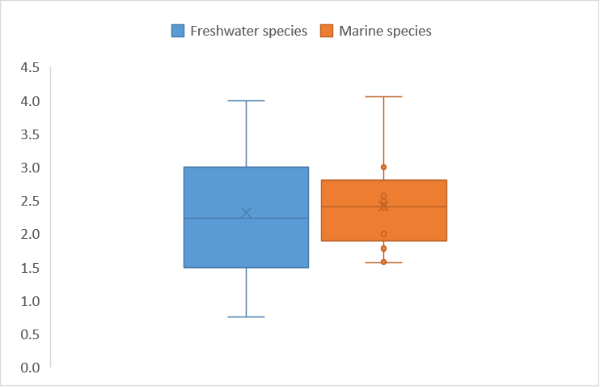

Figure 3. Box plot of the log-transformed ecotoxicity data for freshwater and marine species exposed to simazine

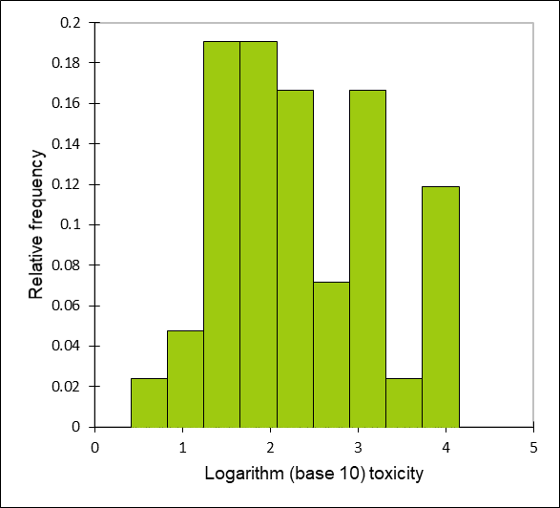Figure 4. Histogram of the log-transformed ecotoxicity data for fresh and marine species exposed to simazine

Calculation of the bimodality coefficient (BC) yielded a value of 0.422, which, being below the indicative threshold BC for bimodality of 0.55, suggested the dataset did not exhibit bimodality. A frequency histogram of the dataset (Figure 4) gave some indication that the dataset may not be unimodal.

1. Do data show taxa-specific sensitivity (i.e. through distinct groupings of different taxa types)?

The relative sensitivity of phototrophs and heterotrophs to simazine was compared using box and whisker plots (Figure 5) and a species sensitivity distribution (Figure 6). These visual analyses indicate that there is not a complete separation in the sensitivity of phototrophs and heterotrophs to simazine. Note that the SSD does not fit the heterotroph data as well as the phototroph data (Figure 5) although overall the SSD fits the combined phototroph and heterotroph ecotoxicity data well.

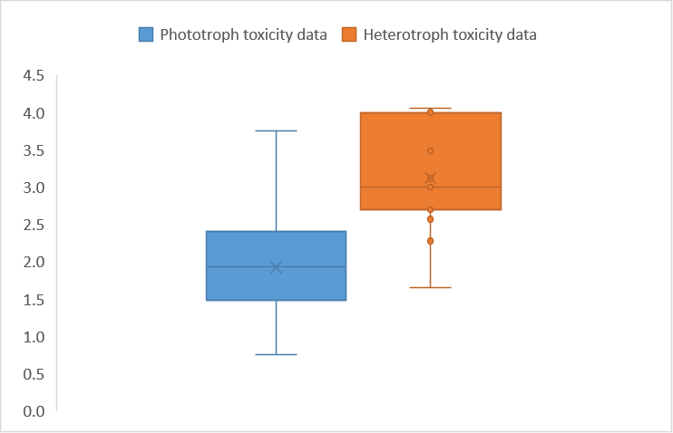

Figure 5. Box and whisker plots of available ecotoxicity data for the different types of fresh and marine organisms exposed to simazine.

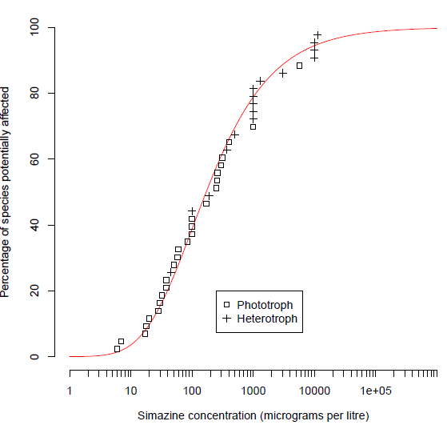

Figure 6. Species sensitivity distribution, generated by Burrlioz 2.0, using available ecotoxicity data for the different types of fresh and marine organisms exposed to simazine

1. Is it likely that indications of bi- or multi-modality or distinct clustering of taxa groups are **not** due to artefacts of data selection, small sample size, test procedures, or other reasons unrelated to a specific mode of action?

Given that there are data for 27 phototrophs and 15 heterotrophs it is likely that the distributions are representative, although a bias cannot be ruled out.

The only line of evidence that supports a bimodal distribution is based on the mode of action of simazine; however, this only provides partial support. Other lines of evidence suggest the data are unimodal. Overall, the available evidence suggests the sensitivity of simazine is likely to be unimodal. Therefore, ecotoxicity data for all species were used to derive DGVs for simazine as per Warne et al (2018). This decision about the modality of simazine ecotoxicity data is consistent with that for atrazine.

## References

AATSE (2002). Pesticide use in Australia. A review undertaken by the Australian Academy of Technological Sciences and Engineering. Australian Academy of Technological Sciences and Engineering, Parkville, Victoria, Australia, 309pp.

ACVM (2020). Agricultural Compounds and Veterinary Medicines (ACVM) register. Minister for Primary Industries New Zealand. [Online] Available at: <https://eatsafe.nzfsa.govt.nz/web/public/acvm-register>. Accessed: 10 January 2020.

ALA (2017). Atlas of Living Australia. Developed by the National Research Infrastructure for Australia (NCRIS) and the Commonwealth Scientific and Industrial Research Organisation (CSIRO). Available from: <https://www.ala.org.au/>, Accessed: May 2017.

Allinson G, Zhang P, Bui AD, Allinson M, Rose G, Marshall S, Pettigrove V (2015). Pesticide and trace metal occurrence and aquatic benchmark exceedances in surface waters and sediments of urban wetlands and retention ponds in Melbourne, Australia. Environmental Science Pollution and Research, 22, 10214–10226.

ANZECC and ARMCANZ (2000). Australian and New Zealand Guidelines for fresh and marine water quality/aquatic ecosystems – Rationale and background information (Chapter 8). Australian and New Zealand Environment and Conservation Council and Agriculture and Resource Management Council of Australia and New Zealand, Canberra, Australian Capital Territory, Australia, 678pp.

APVMA (2009). Simazine. Australian Pesticide and Veterinary Medicine Authority. Last updated 14 January 2009. Available from: <http://archive.apvma.gov.au/archive/our_view/2009/2009-02-19_simazine.php>. Accessed: 2 August 2015.

BCPC (2012). A world compendium. The Pesticide Manual. Sixteenth Edition. MacBean (Ed), British Crop Production Council, Alton, United Kingdom, 1026–1028pp.

Burrlioz 2.0 (2016). Statistical software package to generate trigger values for local conditions within Australia. CSIRO (<http://www.csiro.au>). [Online] Available from: https://research.csiro.au/software/burrlioz/.

CCME (1999). Canadian water quality guidelines for the protection of aquatic life – Simazine. Canadian Council of Ministers of the Environment. Available from: <http://ceqg-rcqe.ccme.ca/download/en/127>. Accessed: 24 June 2015.

Chan CY (2005). Detoxification and degradation of triazine-pollutants by an integrated photochemical-biological system, PhD Thesis, The Chinese University of Hong Kong, China, p.153.

Chen S, Yin C, Strasser RJ, Govinjee, Yang C and Qiang S (2012). Reactive oxygen species from chloroplasts contribute to 3-acetyl-5-isopropyltetramic acid-induced leaf necrosis of *Arabidopsis thaliana*. *Plant Physiology and Biochemi*stry 52, 38–51.

Depledge MH and Billinghurst Z (1999). Ecological significance of endocrine disruption in marine invertebrates, *Marine Pollution Bulletin*, 39,1–12.

Devlin M, Lewis S, Davis A, Smith RA, Negri A, Thompson M and Poggio M (2015). Advancing our understanding of the source, management, transport and impacts of pesticides on the Great Barrier Reef 2011 – 2015. A Centre for Tropical water and Aquatic Ecosystem Research Report (Report No. 15/14) for the Department of Environment and Heritage Protection, 126pp.

Faust M, Altenburger R, Backhaus T, Blanck H, Boedeker W, Gramatica P, Hamer V, Scholze M, Vighi M and Grimme LH (2001). Predicting the joint algal toxicity of multi-component s-triazine mixtures at low-effect concentrations of individual toxicants, *Aquatic Toxicology* 56, 3–32.

Growcom Australia Pty Ltd 2020. Infopest [Online] (2019). *Infopest.*[Online] Available at: [http://www.infopest.com.au](http://www.infopest.com.au/). Accessed: 8 January 2020.

Guiry MD and Guiry GM (2017). AlgaeBase. World-wide electronic publication, National University of Ireland, Galway. Available from: <http://www.algaebase.org>. Accessed: May 2017.

Halliwell B (1991). Oxygen radicals: Their formation in plant tissues and their role in herbicide damage. In: Baker NR and Percival MP (Eds.), Herbicides, Elsevier Science, Amsterdam, pp. 87–129.

Hook SE, Osborn HL, Gissi F, Moncuquet P, Twine NA, Wilkins MR and Adams MS (2014). RNA-seq analysis of the toxicant-induced transcriptome of the marine diatom, *Ceratoneis closterium*, *Marine Genomics* 9(16), 45–53.

ITIS (2017). Integrated Taxonomic Information System. Available from: <https://www.itis.gov/>, Accessed: May 2017.

Knauer K, Homazava N, Junghans M and Werner I (2016). The influence of particles on bioavailability and toxicity of pesticides in surface waters. *Integrated Environmental Assessment and Management:* 13: 585–600.

Knuteson SL, Whitwell T and Klaine SJ (2002). Influence of plant age and size on simazine toxicity and uptake*, Journal of Environmental Quality* 31, 2096–2103.

Mnif W, Hassine AIH, Bouaziz A, Bartegi A, Thomas O and Roig B (2011). Effect of endocrine disruptor pesticides: A review. *International Journal of Environmental Research and Public Health* 8, 2265–2303.

Moore A and Lower N (2001). The impact of two pesticides on olfactory-mediated endocrine function in mature male Atlantic salmon (*Salmo salar* L.) parr. *Comparative Biochemistry and Physiology Part B:* *Biochemistry and Molecular Biology* 129, 269–276.

Oropesa AL, García-Cambero JP and Soler F (2009a). Effect of a subchronic exposure to simazine on energetic metabolism of Common Carp (*Cyprinus carpio*), *Journal of Environmental Science and Health*, Part B: Pesticides, Food Contamination and Agricultural Wastes 44, 144–156.

Oropesa AL, García-Cambero JP, Gomez L, Roncero V and SolerF (2009b). Effect of long-term exposure to simazine on histopathology, hematological, and biochemical parameters in *Cyprinus carpio*, *Environmental Toxicology* 24, 187–199.

Piletska EV, Turner NW, Turner APF and Piletsky SA (2005). Controlled release of the herbicide simazine from computationally designed molecularly imprinted polymers, *Journal of Controlled Release* 108(1), 132–139.

Ramel F, Sulmon C, Bogard M, Couée I and Gouesbet G (2009). Differential patterns of reactive oxygen species and antioxidative mechanisms during atrazine injury and sucrose-induced tolerance in *Arabidopsis thaliana* plantlets. *BMC Plant Biology* 9:28 doi:10.1186/1471-2229-9-28.

Roskov Y, Abucay L, Orrell T, Nicolson D, Bailly N, Kirk PM, Bourgoin T, DeWalt RE, Decock W, De Wever A, Nieukerken E, Zarucchi J, Penev L, eds. (2017). Species 2000 & ITIS Catalogue of Life, 30th April 2017. Digital resource available from: [www.catalogueoflife.org/col](http://www.catalogueoflife.org/col). Species 2000: Naturalis, Leiden, the Netherlands. ISSN 2405-8858. Accessed: May 2017.

Stara A, Machova J and Velisek J (2012). Effect of chronic exposure to simazine on oxidative stress and antioxidant response in common carp (*Cyprinus carpio* L.). *Environmental Toxicology and Pharmacology* 33, 334–343.

Stone WW, Gilliom RJ and Martin JD (2014). An overview comparing results from two decades of monitoring for pesticides in the Nation’s streams and Rivers, 1992–2001 and 2002–2011: U.S. Geological Survey Scientific Investigations Report 2014–5154, 23p., Available from: <http://dx.doi.org/10.3133/sir20145154>. Accessed: 24 June 2015.

Sunderam RIM, Warne MStJ, Chapman JC, Pablo F, Hawkins J, Rose RM and Patra RW (2000). The ANZECC and ARMCANZ Water Quality Guideline Database for Toxicants. Supplied as part of a CD-ROM in the ANZECC and ARMCANZ (2000) Australian and New Zealand Guidelines for Fresh and Marine Water Quality.

Suwanchaichinda C and Brattsten LB (2001). Effects of Exposure to pesticides on carbaryl toxicity and cytochrome P450 activities in *Aedes albopictus* larvae (Diptera: Culicidae*), Pesticide Biochemistry and Physiology* 70, 63–73.

United Nations Environment Programme and the World Health Organization (2013). In: Bergman Å, Heindel JJ, Jobling S, Kidd KA, Zoeller RT.(Eds.), State of the Science of Endocrine Disrupting Chemicals - 2012, p. 289.

University of Hertfordshire (2013). The Pesticide Properties Data Base (PPDB). Developed by the Agriculture & Environment Research Unit (AERU), University of Hertfordshire, 2006–2013. Available from: <http://sitem.herts.ac.uk/aeru/ppdb/en/Reports/27.htm>. Accessed: 13 May 2016.

USEPA (2015a). ECOTOX User Guide: ECOTOXicology Database System. Version 4.0. United States Environmental Protection Agency. Available from: <http://cfpub.epa.gov/ecotox/>. Accessed: May–September 2015.

USEPA (2015b). Office of Pesticide Programs Database. Office of Prevention, Pesticides, and Toxic Substances, United States Environmental Protection Agency, Office of Pesticide Programs. Washington, D.C. January 23, 2004. Available from: <https://ecotox.ipmcenters.org/index.cfm?menuid=5>. Accessed: February–April 2016, 05/08/2019.

Vandergragt ML, Warne MStJ, Borschmann G, Johns CV. 2020. Pervasive pesticide contamination of wetlands in the Great Barrier Reef Catchment Area. *Integrated Environmental Assessment and Management*, 16 (6), 968 – 982.

Velisek J, Kouba A and Stara A (2013). Acute toxicity of triazine pesticides to Juvenile Signal Crayfish (*Pacifastacus leniusculus*), *Neuroendocrinology Letters* 34, 31–36.

Wallace R, Huggins R, King O, Gardiner R, Thomson B, Orr DN, Ferguson B, Taylor C, Smith RA, Warne MStJ, Turner RDR, Mann RM (2016). Total suspended solids, nutrient and pesticide loads (2014–2015) for rivers that discharge to the Great Barrier Reef – Great Barrier Reef Catchment Loads Monitoring Program. Department of Science, Information Technology and Innovation. Brisbane, 111pp. Available from: <http://www.reefplan.qld.gov.au/measuring-success/paddock-to-reef/assets/2014-2015-gbr-catchment-loads-technical-report.pdf>. Accessed: January 2020.

Wallace R, Huggins R, Smith RA, Turner R, Garzon-Garcia A and Warne MStJ (2015). Total suspended solids, nutrients and pesticide loads (2012–2013) for rivers that discharge to the Great Barrier Reef – Great Barrier Reef Catchment Loads Monitoring Program 2012–2013. Department of Science, Information Technology, Innovation and the Arts, Brisbane, Queensland, 99pp. Available from: <http://www.reefplan.qld.gov.au/measuring-success/paddock-to-reef/assets/2012-2013-gbr-catchment-loads-report.pdf>. Accessed: January 2020.

Warne MStJ (2001). Description of how each toxicant trigger value was derived. CD-ROM in the ANZECC and ARMCANZ (2000) Australian and New Zealand Guidelines for Fresh and Marine Water Quality, Canberra, Australia.

Warne MStJ, Batley GE, van Dam RA, Chapman JC, Fox DR, Hickey CW and Stauber JL (2018). Revised Method for Deriving Australian and New Zealand Water Quality Guideline Values for Toxicants – update of 2015 version. Prepared for the revision of the Australian and New Zealand Guidelines for Fresh and Marine Water Quality. Australian and New Zealand Governments and Australian state and territory governments, Canberra, 48 pp.

Warne MStJ, Smith RA, Turner RDR. 2020. Analysis of mixtures of pesticides discharged to the Great Barrier Reef, Australia. *Environmental Pollution, 265, 114088.*

Warne MStJ, Westbury A-M and Sunderam R (1998). A compilation of toxicity data for chemicals to Australasian aquatic species. Part 1: Pesticides, *Australasian Journal of Ecotoxicolog*y, 4, 93–144.

Wilkinson AD, Collier CJ, Flores F, Langlois L, Ralph PJ and Negri AP (2017). Combined effects of temperature and the herbicide diuron on photosystem II activity of the tropical seagrass *Halophila ovalis*. *Scientific Reports*, 7(1), 45404. doi: 10.1038/srep45404.

Wilson PC, Whitwell T and Klaine SJ (2000). Metalaxyl and simazine toxicity to and uptake by *Typha latifolia*. *Archives of Environmental Contamination and Toxicology* 39(3), 282–288.

WoRMS Editorial Board (2017). World Register of Marine Species. Available from: <http://www.marinespecies.org> at VLIZ, Accessed: May 2017.