# Water Quality Guidelines is a joint initiative of the Australian and New Zealand governments, in partnership with the Australian states and territories.Toxicant default guideline values for aquatic ecosystem protection

Simazine in freshwater

Technical brief

November 2024

© Commonwealth of Australia 2024

**Ownership of intellectual property rights**

Unless otherwise noted, copyright (and any other intellectual property rights, if any) in this publication is owned by the Commonwealth of Australia (referred to as the Commonwealth).

**Creative Commons licence**

by

All material in this publication is licensed under a Creative Commons Attribution 4.0 Australia Licence, save for content supplied by third parties, photographic images, logos and the Commonwealth Coat of Arms.

Creative Commons Attribution 4.0 Australia Licence is a standard form licence agreement that allows you to copy, distribute, transmit and adapt this publication provided you attribute the work. See the [summary of the licence terms](https://creativecommons.org/licenses/by/4.0/) or the [full licence terms](https://creativecommons.org/licenses/by/4.0/legalcode).

Inquiries about the licence and any use of this document should be emailed to [copyright@dcceew.gov.au](mailto:copyright@dcceew.gov.au).

**Cataloguing data**

This publication (and any material sourced from it) should be attributed as: ANZG 2024, *Toxicant default guideline values for aquatic ecosystem protection: Simazine in freshwater*. Australian and New Zealand Guidelines for Fresh and Marine Water Quality. CC BY 4.0. Australian and New Zealand Governments and Australian state and territory governments, Canberra, ACT, Australia.

This publication is available at <https://www.waterquality.gov.au/anz-guidelines/guideline-values/default/water-quality-toxicants/toxicants>.

**Contact**

Australian Government Department of Climate Change, Energy, the Environment and Water

GPO Box 3090 Canberra ACT 2601

General enquiries: 1800 920 528

Email [waterquality@dcceew.gov.au](mailto:waterquality@dcceew.gov.au)

**Disclaimer**

The author(s) of this publication, all other entities associated with funding this publication or preparing and compiling this publication, and the publisher of this publication, and their employees and advisers, disclaim all liability, including liability for negligence and for any loss, damage, injury, expense or cost incurred by any person as a result of accessing, using or relying on any of the information or data in this publication to the maximum extent permitted by law.

**Acknowledgements**

The default guideline values (DGVs) were derived by Olivia C King and Dr Rachael A Smith (Queensland Department of Environment and Science (DES)), Gabrielle Dern (Griffith University) and Dr Michael St J Warne (University of Queensland, DES). The DGVs were peer reviewed by two anonymous reviewers, by Dr Reinier Mann (DES), and by contracted technical advisors Dr Rick van Dam and Dr Melanie Trenfield. The DGVs were also reviewed and approved by jurisdictional, technical and policy oversight groups and the National Water Committee.



Contents

1 Introduction 1

2 Aquatic toxicology 2

2.1 Mechanisms of toxicity 2

2.2 Relative toxicity 2

3 Factors affecting toxicity 3

4 Default guideline value derivation 3

4.1 Toxicity data used in derivation 3

4.2 Species sensitivity distribution 6

4.3 Default guideline values 6

4.4 Reliability classification 7

Glossary 8

Appendix A: Toxicity data that passed the screening and quality assessment and were used to derive the default guideline values 10

Appendix B: Modality assessment for simazine toxicity to aquatic species 14

References 18

Figures

Figure 1 Structure of simazine 1

Figure 2 Species sensitivity distribution, simazine in freshwater 6

Tables

Table 1 Summary of selected physico-chemical properties of simazine 1

Table 2 Summary of single chronic toxicity values, for all species used to derive default guideline values for simazine in freshwater 5

Table 3 Default guideline values, simazine in freshwater, very high reliability 7

Appendix figures

Figure B 1 Box plot, comparing freshwater and marine species sensitivities to simazine 15

Figure B 2 Histogram, log-transformed ecotoxicity data for freshwater and marine species 15

[Figure B 3 Box and whisker plots, comparison of phototroph and heterotroph sensitivity to   
simazine 16](#_Toc166855153)

Figure B 4 Species sensitivity distribution, phototroph and heterotroph sensitivity to simazine 16

Appendix tables

Table A 1 Summary, chronic toxicity data that passed the screening and quality assessment processes, simazine in freshwater 10

Summary

The default guideline values (DGVs) and associated information in this technical brief should be used in accordance with the detailed guidance provided in the Australian and New Zealand Guidelines for Fresh and Marine Water Quality website (www.waterquality.gov.au/anz-guidelines).

Simazine (6-chloro-N2, N4-diethyl-1,3,5-triazine-2,4-diamine, CAS no. 122-34-9) is a selective systemic triazine herbicide or, more specifically, a chlorotriazine herbicide. Other chlorotriazine herbicides include atrazine, propazine and terbuthylazine. Simazine is a photosynthesis-inhibiting herbicide commonly used to control a large variety of weeds and annual grasses in agriculture (for cropping and non-cropping purposes), forestry and a range of urban and industrial settings (Ministry for Primary Industries New Zealand 2020; APVMA 2023).

The previous DGV for simazine in freshwater was a moderate reliability value (ANZECC/ARMCANZ 2000) and was based on a mixture of chronic and acute toxicity data for 12 species from four taxonomic groups (i.e. fish, crustaceans, insects and algae) (Warne 2001). More data on simazine toxicity to freshwater species are now available, including data from phototrophs, which enable the calculation of very high reliability DGVs.

Simazine has a specific mode of action (inhibition of the photosystem II pathway (PSII)) and a non-specific mode of action (formation of reactive oxygen species (ROS)) and can exert biochemical effects such as endocrine disruption in non-target organisms. (Endocrine disrupting effects are generally not considered in the derivation of DGVs.) This indicates that simazine should be more toxic to phototrophs than to heterotrophs. However, the various lines of evidence (Appendix B: Modality assessment for simazine toxicity to aquatic species) indicate no difference in the sensitivity of phototrophs and heterotrophs, so the DGVs were derived using toxicity data for both groups. The lowest reported chronic toxicity value for freshwater species is 32 µg/L (freshwater microalga, 3 d NOEC) and the lowest reported acute toxicity value for freshwater species is 0.65 µg/L (freshwater microalga, 1 d NOEC).

Very high reliability DGVs for simazine in freshwater were derived based on data for 20 freshwater phototrophic and heterotrophic species from four phyla and six classes, with a good fit to the species sensitivity distribution (SSD) to the toxicity data. The DGVs derived here are expressed in terms of the active ingredient (simazine) rather than commercial formulations. The DGVs for 99%, 95%, 90% and 80% species protection are 6.1 µg/L, 12 µg/L, 18 µg/L and 29 µg/L respectively. The 95% DGV is recommended for adoption in the assessment of slightly to moderately disturbed ecosystems.

## Introduction

Simazine (CAS no. 122-34-9) is a triazine herbicide (C7H12ClN5; Figure 1 Structure of simazine) that is a white powder at room temperature (approximately 20–22°C). It is the active ingredient of a variety of commercial herbicide formulations. In Australia, most commercial formulations of simazine do not contain any other herbicides. However, simazine may be mixed with other herbicides in on-farm tank mixes to increase its efficacy. Physico-chemical properties of simazine that may affect its environmental fate and toxicity are in Table 1.

Diagram displays the chemical structure of simazine.

Figure 1 Structure of simazine

Table 1 Summary of selected physico-chemical properties of simazine

| Physico-chemical property | Value |
| --- | --- |
| Molecular weight | 201.7 amu **a** |
| Aqueous solubility | 6.2 mg/L at pH 7 and 22°C **a** 5 mg/L at 20°C **b** |
| Logarithm of the octanol-water partition coefficient (log Kow) | 2.1 **a**2.3 at pH 7 and 20°C **b** |
| Logarithm of the organic carbon water partition coefficient (log Koc) | 2.20 **a**2.14 at 25°C **b** |
| Logarithm of the bioconcentration factor (log BCF) | 2.34 **b** <2.0 **c** |
| Half-life in water (t1/2) | Freshwater: 8.8 d at pH 1, 96 d at pH 5, 3.7 d at pH 13 **a**Marine: 579 ± 294 d (dark, at 25°C),  96 d at pH 7 and 20°C **b** |
| Half-life in soils (t1/2) | Field: 90 d **b**Lab: 60 d **b** |

**a** MacBean and BCPC (2012).

**b** University of Hertfordshire (2013).

**c** CCME (1999).

Simazine belongs to the chlorotriazine group within the triazine herbicides, which also include atrazine, propazine and terbuthylazine. Simazine is a pre-emergent herbicide; it is used as both a knockdown and residual herbicide and it can retain its biological effectiveness for at least 9 months after application (APVMA 2023). In Australia and New Zealand, simazine is approved for weed control in agriculture (e.g. apples, asparagus, berries, broad beans, chickpeas, citrus, grapes, lucerne, pears and wheat), forestry, and a range of urban and industrial uses (e.g. weed control around buildings, drains, roadsides, footpaths and other commercial and public land) (Ministry for Primary Industries New Zealand 2020; APVMA 2023).

Simazine has poor-to-moderate soil-binding characteristics due to its low log Koc value (Table 1). Although it has a low aqueous solubility, it has a long half-life in aquatic environments (Table 1) and is frequently detected in surface water and ground water throughout Europe (Oropesa et al. 2009b), the US (Stone et al. 2014) and eastern Australia (Allinson et al. 2015; Devlin et al. 2015; Wallace et al. 2015, 2016; Vandergragt et al. 2020; Warne et al. 2020). Due to its widespread detection at elevated concentrations and its broad range of adverse effects, simazine is included in the EU Priority Pollutants List and the equivalent USEPA list (Stara et al. 2012).

## Aquatic toxicology

### Mechanisms of toxicity

Simazine is mainly absorbed through the roots of plants and transported to the leaves, where it exerts its toxicity. Simazine exerts its toxicity in aquatic plants (including macrophytes and algae) by inhibiting electron transport in the photosystem II (PSII) complex (University of Hertfordshire 2013), a key process in photosynthesis that occurs in the thylakoid membranes of chloroplasts. Photosynthesis-inhibiting herbicides bind to the plastoquinone B protein-binding site on the D1 protein in PSII. This prevents the transport of electrons to synthesise adenosine triphosphate (used for cellular metabolism) and nicotinamide adenine dinucleotide phosphate (used in converting CO2 to glucose), therefore preventing CO2 fixation (Wilson and Wilson 2010).

In addition to its main mode of action, exposure to PSII-inhibiting herbicides can increase the formation or accumulation of reactive oxygen species (ROS), (Halliwell 1991; Ramel et al. 2009). ROS are highly reactive forms of oxygen that readily react with, and bind to, biomolecules including deoxyribonucleic acid (DNA) and ribonucleic acid (RNA). ROS are created during normal cellular functioning, particularly in biochemical processes that involve the generation of energy (e.g. photosynthesis in chloroplasts; Krebs cycle in mitochondria) (Chen et al. 2012). In phototrophs, ROS are formed when the absorbed light energy exceeds the ability to convert CO2 to organic molecules, thus accumulating oxygen (Chen et al. 2012). Prolonged exposure to elevated concentrations of ROS in plants, as a result of biotic (e.g. disease) and/or abiotic (e.g. PSII-inhibiting herbicides) stressors, can cause irreversible cell damage and ultimately lead to cell death (apoptosis).

While simazine predominantly targets the PSII complex, it can also exert biochemical effects in non-target organisms. It is also known to cause endocrine-disrupting effects (Depledge and Billinghurst 1999; Mnif et al. 2011; Bergman et al. 2013). For example, concentrations of 1–2 µg/L can inhibit the endocrine-mediated olfactory response of male Atlantic salmon (*Salmo salar* L.) to the female priming pheromone prostaglandin (Moore and Lower 2001).

### Relative toxicity

There were toxicity data for 29 freshwater species that passed the screening and quality assessment processes. Species consisted of 17 freshwater phototrophs and 12 heterotrophs. The phototrophs consisted of eight green algae, seven macrophytes, a single diatom and a single blue–green alga. The heterotrophs consisted of five fish, five crustaceans and two insects.

Generally, phototrophs are more sensitive than heterotrophs, although there is considerable overlap in sensitivity between the two groups; many heterotrophs have toxicity values within the range of phototroph values. Based on multiple lines of evidence (Appendix B: Modality assessment for simazine toxicity to aquatic species), it was difficult to determine a difference in the sensitivity of phototrophs and heterotrophs.

The 10 species of freshwater algae for which there are simazine toxicity data range in sensitivity from 0.65 µg/L for *Scenedesmus acutus* (acute NOEC (Faust et al. 2001)) to 56 900 µg/L for *S. vacuolatus* (acute EC50 (Faust et al. 2001)). *S. vacuolatus* was approximately 40 times less sensitive than the next least sensitive alga (*S. obliquus*, chronic IC50 of 1 498 µg/L (Chan 2005)). The seven macrophytes had a similar—albeit narrower—range of sensitivity compared to the algae, from 50 µg/L for *Myriophyllum aquaticum* (7 d chronic LOEC (Knuteson et al. 2002)) to 1 000 µg/L for *Typha latifolia* (chronic 7 d LOEC (Wilson et al. 2000a)). Toxicity data for eight macroinvertebrates indicated they were generally less sensitive than phototrophs, ranging from 1 100 µg/L for *Daphnia magna* (acute 4 d EC50 (USEPA 2015)) to 100 000 µg/L for *Procambarus* sp. (acute 2 d LC50 (USEPA 2015)). Fish were generally less sensitive than phototrophs, ranging from 45 µg/L for *Cyprinus carpio* (chronic 90 d NOEC (Oropesa et al. 2009b)) to 51 000 µg/L for *Pimephales promelas* (acute 4 d LC50 (USEPA 2015)).

## Factors affecting toxicity

As with many organic chemicals, it is expected that dissolved and particulate organic matter and suspended solids would affect the bioavailability and toxicity of simazine. However, any such effect would be relatively minor given its relatively low log Koc value. As noted in Section 2.1, one of the modes of action of simazine is to increase the formation of ROS. Given that the formation of ROS depends on the presence of light, it is plausible that increased turbidity (e.g. from suspended solids) could decrease simazine toxicity. However, the information on this potential toxicity modifying factor for PSII herbicides is contradictory. Wilkinson et al. (2017) found that decreased light intensity had a significant antagonistic effect on the toxicity of diuron (a PSII herbicide) to the seagrass *Halophila ovalis*. In contrast, a major review by Knauer et al. (2016) concluded that the presence of suspended solids did not significantly decrease the toxicity of a range of pesticides including atrazine (a PSII herbicide) to freshwater species. There appear to be no such data for simazine.

## Default guideline value derivation

The DGVs were derived in accordance with the method described in Warne et al. (2018) and using Burrlioz 2.0 software.

### Toxicity data used in derivation

To obtain data for simazine toxicity to freshwater organisms, the scientific literature was searched. In addition, the following databases were searched: ECOTOX Knowledgebase (USEPA 2015), Office of Pesticide Programs Database (USEPA 2015), Australasian Ecotoxicology Database (Warne et al. 1998) and ANZECC/ARMCANZ (2000) toxicant databases (Sunderam et al. 2000). There were sufficient simazine toxicity data to calculate the DGVs (Appendix A: Toxicity data that passed the screening and quality assessment and were used to derive the default guideline values). All the toxicity data used to calculate the DGVs were determined from experiments using simazine with a minimum purity of 80% active ingredient (Warne et al. 2018).

There were toxicity data for 29 freshwater species (17 phototrophs and 12 heterotrophs representing six phyla and 10 classes) that passed the screening and quality assessment processes. The represented phyla were Arthropoda, Chlorophyta, Chordata, Cyanobacteria, Bacillariophyta and Tracheophyta. The 10 classes were Actinopterygii (which accounts for approximately 99% of fish), Bacillariophyceae (diatoms), Branchiopoda (crustaceans), Chlorophyceae (green algae), Cyanophyceae (cyanobacteria), Insecta (invertebrates), Liliopsida (monocotyledons), Magnoliopsida (dicotyledons), Malacostraca (crustaceans) and Trebouxiophyceae (green algae). Chronic toxicity data were available for 20 of the 29 species, comprising 14 phototrophs and six heterotrophs, while acute toxicity data were available for nine species, comprising three phototrophs and six heterotrophs.

As noted in Section 2, the specific mode of action of simazine on plant photosynthesis indicates that phototrophs should be more sensitive than non-phototrophic species. However, simazine and other PSII-inhibiting herbicides also exert toxicity by increasing the synthesis of ROS and can cause endocrine disruption. A modality assessment of the simazine toxicity data (to both marine and freshwater species) was undertaken according to the weight-of-evidence approach described by Warne et al. (2018). Most lines of evidence supported the conclusion that the dataset was unimodal, with no clear difference between the sensitivity of phototrophs and heterotrophs (Appendix B: Modality assessment for simazine toxicity to aquatic species). Therefore, as recommended by Warne et al. (2018), toxicity data for all available organisms were used to calculate the DGVs.

Freshwater chronic negligible effect data (i.e. NOEC, NOAEC) were available for only six species from three phyla. This did not meet the minimum data requirements to use a species sensitivity distribution (SSD) method (i.e. at least five species from at least four phyla (Warne et al. 2018)). Therefore, the dataset was expanded to include chronic LOEC and EC50 data that were then converted to estimates of chronic NOEC data by dividing by 2.5 and 5 respectively. This resulted in a dataset with toxicity data for 20 freshwater phototrophs and heterotrophs that belonged to six phyla and eight classes, which met the minimum data requirements to derive DGVs using an SSD. The final dataset included six NOECs (including one NOAEC), five (converted) LOECs and nine (converted) EC50s.

A summary of the toxicity data (one value per species) used to calculate the DGVs for simazine in freshwater is in Table 2; additional details are in Appendix A: Toxicity data that passed the screening and quality assessment and were used to derive the default guideline values. Details of the data quality assessment and the data that passed the quality assessment are provided as supporting information.

Table 2 Summary of single chronic toxicity values, for all species used to derive default guideline values for simazine in freshwater

| Taxonomic group | Species | Life stage | Duration (d) | Toxicity measure (endpoint) | Toxicity value (µg/L) | Final toxicity value (µg/L) |
| --- | --- | --- | --- | --- | --- | --- |
| Arthropoda | *Daphnia magna* | – | 21 | LOEC (mortality) | 2 500 | 1 000 **a** |
| Bacillariophyta | *Navicula pelliculosa* **c** | – | 5 | EC50 (cell density) | 90 **b** | 18 **a** |
| Chlorophyta | *Chlamydomonas geitleri* | Exponential growth phase | 3 | EC50 (growth rate) | 855 **b** | 171 **a** |
| *Chlorella pyrenoidosa* **c** | – | 6 | EC50 (abundance) | 327 | 65 **a** |
| *Chlorella vulgaris* **c** | – | 4 | EC50 (abundance) | 2173 | 435 **a** |
| *Pseudokirchneriella subcapitata* **d** | – | 3 | NOEC (growth rate) | 32 | 32 |
| *Scenedesmus obliquus* **c** | – | 4 | EC50 (growth rate) | 257 | 51.4 **a** |
| *Scenedesmus quadricauda* | – | 4 | EC50 (abundance) | 150 | 30 **a** |
| Chordata | *Carassius auratus* | – | 365 | LOEC (mortality) | 2 500 | 1 000 **a** |
| *Cyprinus carpio* | – | 90 | NOEC (weight/mortality) | 45 **b** | 45 |
| *Lepomis macrochirus* | – | 365 | LOEC (mortality) | 2 500 | 1 000 **a** |
| *Oncorhynchus mykiss***c** | – | 28 | EC50 (mortality) | 2 500 | 500 **a** |
| *Pimephales promelas* | Early life stage | 120 | LOEC (mortality) | 2 500 | 1 000 **a** |
| Cyanobacteria | *Anabaena flos-aquae* | – | 5 | EC50 (cell density) | 36 | 7.2 **a** |
| Tracheophyta | *Acorus gramineus* | – | 7 | NOEC (fresh weight) | 100 | 100 |
| *Lemna gibba* | – | 14 | EC50 (biomass yield) | 140 | 28 **a** |
| *Myriophyllum aquaticum* **c** | 2 weeks old | 7 | LOEC (fresh weight) | 50 | 20 **a** |
| *Pontederia cordata* | – | 7 | NOEC (fresh weight) | 100 | 100 |
| *Typha latifolia* **c** | – | 7 | NOEC  (fresh weight) | 300 | 300 |
| *Vallisneria americana* | – | 13 | NOAEC  (length) | 58 | 58 |

–: Not stated / no data available.

**a** Chronic LOEC and EC50 values that were converted to chronic NOEC values by dividing by 2.5 and 5, respectively (Warne et al. 2018).

**b** Geometric mean.

**c** Species that originated from, or whose geographic distributions include, Australia and/or New Zealand.

**d** This species has also been called *Raphidocelis subcapitata* and *Selenastrum caprincornutum*.

To identify species that were relevant to Australia and New Zealand ecosystems, the following databases were searched: AlgaeBase (Guiry and Guiry 2017), Atlas of Living Australia (ALA 2017), Catalogue of Life (Roskov et al. 2017), Integrated Taxonomic Information System (ITIS 2017), and the World Register of Marine Species (WoRMS 2017). The dataset used in the DGV derivation for simazine in freshwater (Table 2) includes toxicity data for seven freshwater species that originated from, or are distributed within, Australia and/or New Zealand.

### Species sensitivity distribution

The cumulative frequency (species sensitivity) distribution (SSD) of the 20 freshwater phototrophs and heterotrophs that was used to derive the DGVs is presented in Figure 2. The SSD was plotted using Burrlioz 2.0 software. Notwithstanding the stacking of four toxicity values at the top of the SSD, the model provides a good fit to the data.

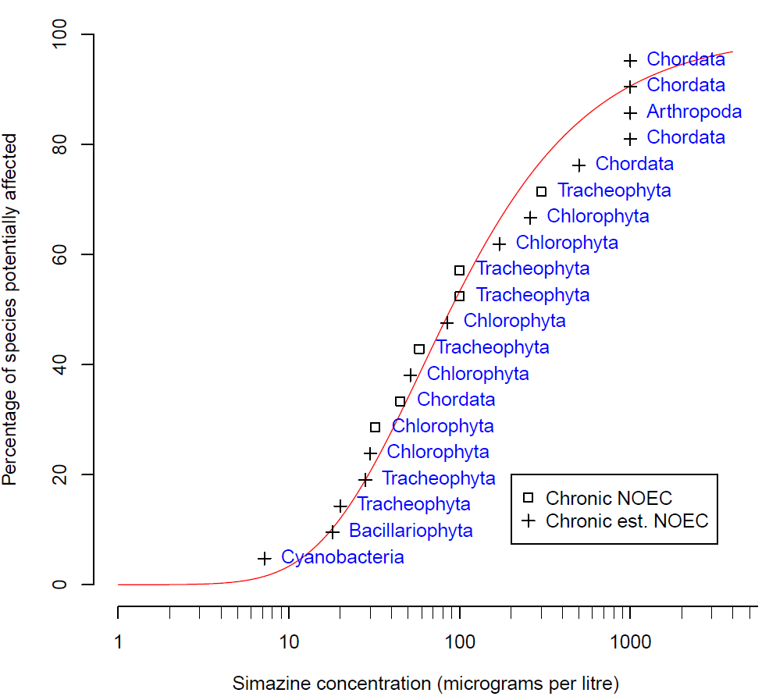

Figure 2 Species sensitivity distribution, simazine in freshwater

### Default guideline values

It is important that the DGVs (Table 3) and associated information in this technical brief are used in accordance with the detailed guidance provided in the Australian and New Zealand Guidelines for Fresh and Marine Water Quality website (ANZG 2018).

The DGVs for simazine are expressed in terms of the concentration of the active ingredient. Although some of the simazine toxicity data used to derive the DGVs may have included a component of toxicity that could be attributed to simazine metabolites, this has not been quantified; therefore, only simazine (not its metabolites) should be measured for comparison with the DGVs.

Measured log BCF values for simazine are low (Table 1) and below the threshold at which secondary poisoning must be considered (i.e. log BCF 4 (Warne et al. 2018)). Therefore, the DGVs for simazine do not need to account for secondary poisoning.

The DGVs for simazine in freshwater are provided in Table 3. The 95% species protection DGV of 12 µg/L is recommended for application to slightly-to-moderately disturbed ecosystems.

Table 3 Default guideline values, simazine in freshwater, very high reliability

| Level of species protection (%) | DGV for simazine in freshwater (µg/L) ****a**** |
| --- | --- |
| 99 | 6.1 |
| 95 | 12 |
| 90 | 18 |
| 80 | 29 |

**a** Default guideline values were derived using Burrlioz 2.0 software and rounded to two significant figures.

### Reliability classification

The simazine freshwater DGVs have a very high reliability classification (Warne et al. 2018) based on the outcomes for the following three criteria:

* sample size—20 (preferred)
* type of toxicity data—chronic
* SSD model fit—good (Burr Type III).

## Glossary

| Term | Definition |
| --- | --- |
| acute toxicity | A lethal or adverse sub-lethal effect that occurs as the result of a short exposure period to a chemical relative to the organism’s life span. |
| bimodal | Having two modes of distribution (of the sensitivity of species to a toxicant). This typically occurs with chemicals with specific modes of action. For example, herbicides are designed to affect plants at low concentrations, but most animals are only affected at high concentrations. |
| chemical abstracts service (CAS) no. | A unique identifying number that is allocated to each chemical by the American Chemical Society. |
| chronic toxicity | An adverse effect that occurs as the result of exposure to a chemical for a substantial portion of the organism’s life span or an adverse sub-lethal effect on a sensitive early life stage. Refer to Warne et al. (2018) for examples of chronic exposures. |
| default guideline value (DGV) | A guideline value recommended for generic application in the absence of a more specific guideline value (e.g. site-specific guideline value), in the Australian and New Zealand Water Quality Guidelines. Formerly known as ‘trigger value’. |
| ECx | The concentration of a substance in water or sediment that is estimated to produce a x% change in the response being measured or a certain effect in x% of the test organisms relative to the control response, under specified conditions. |
| EC50(median effective concentration) | The concentration of a substance in water or sediment that is estimated to produce a 50% change in the response being measured or a certain effect in 50% of the test organisms relative to the control response, under specified conditions. |
| endpoint | The specific response of an organism that is measured in a toxicity test (e.g. mortality, growth, a particular biomarker). |
| guideline value | A measurable quantity (e.g. concentration) or condition of an indicator for a specific environmental value below which (or above which, in the case of stressors such as pH, dissolved oxygen and many biodiversity responses) there is considered to be a low risk of unacceptable effects occurring to that community value. Guideline values for more than one indicator should be used simultaneously in a multiple lines of evidence approach. |
| heterotrophs | Plants and animals that are dependent on organic matter for a carbon source. |
| IC50 | The concentration of a substance in water or sediment that is estimated to produce a 50% inhibition of the response being measured in test organisms, relative to the control response, under specified conditions. |
| LC50 (median lethal concentration) | The concentration of a substance in water or sediment that is estimated to be lethal to 50% of a group of test organisms, relative to the control response, under specified conditions |
| LOEC (lowest observed effect concentration) | The lowest concentration of a chemical used in a toxicity test that has a statistically significant (p≤0.05) adverse effect on the exposed population of test organisms compared to the controls. All higher concentrations should also cause statistically significant effects. The LOEL (lowest observed effect level) is synonymous with the LOEC. |
| mode of action | The means by which a chemical exerts its toxic effects. For example, triazine herbicides inhibit the photosystem II component of plants photosynthesis biochemical reaction. |
| NOEC (no observed effect concentration) | The highest concentration of a material used in a toxicity test that has no statistically significant adverse effect on the exposed population of test organisms as compared with the controls. The NOAEC (no observed adverse effect concentration) is synonymous with the NOEC. |
| phototrophs | Organisms (e.g. plants and algae) that are dependent on photosynthesis for food. |
| PSII | Photosystem II of the photosynthetic biochemical pathway. |
| ROS (reactive oxygen species) | Highly reactive forms of oxygen that readily react with, and bind to, biomolecules including deoxyribonucleic acid (DNA) and ribonucleic acid (RNA). |
| site-specific | Relating to something that is confined to, or valid for, a particular place. Site-specific trigger values are relevant to the location or conditions that are the focus of a given assessment. |
| species (biological) | A group of organisms that resemble each other to a greater degree than members of other groups and that form a reproductively isolated group that will not produce viable offspring if bred with members of another group. |
| SSD (species sensitivity distribution) | A method that plots the cumulative frequency of species’ sensitivities to a toxicant and fits a statistical distribution to the data. From the distribution, the concentration that should theoretically protect a selected percentage of species can be determined. |
| toxicity | The inherent potential or capacity of a material to cause adverse effects in a living organism. |
| toxicity test | The means by which the toxicity of a chemical or other test material is determined. A toxicity test is used to measure the degree of response produced by exposure to a specific level of stimulus (or concentration of chemical) for a specified test period. |
| unimodal | Having one mode of distribution (of the sensitivity of species to a toxicant). |

## Appendix A: Toxicity data that passed the screening and quality assessment and were used to derive the default guideline values

Table A 1 Summary, chronic toxicity data that passed the screening and quality assessment processes, simazine in freshwater

| Taxonomic group | Species | Life stage | Exposure duration (d) | Toxicity measure (test endpoint) | Test medium | Temp. (°C) | pH | Concentration (µg/L) | Reference |
| --- | --- | --- | --- | --- | --- | --- | --- | --- | --- |
| Arthropoda | *Daphnia magna* | – | 21 | LOEC (mortality) | Surface or ground, reconstituted or dechlorinated tap water | 20 ± 1 | – | 2 500 | USEPA (2015) |
| – | | | | | | | **1 000 a** | **Value used in SSD** |
| Bacillariophyta | *Navicula pelliculosa***b** | – | 5 | EC50  (cell density) | Algal nutrient medium | 20 - 24 ± 2 | – | 90 | USEPA (2015) |
| – | | | | | | | **18 a** | **Value used in SSD** |
| Chlorophyta | *Chlamydomonas geitleri* | Exponential growth phase | 3 | EC50  (growth rate) | Fresh water | 23 | 7.8 | 1 032 | Francois and Robinson (1990) |
| Exponential growth phase | 3 | EC50  (growth rate) | Fresh water | 23 | 7.8 | 812 | Francois and Robinson (1990) |
| Exponential growth phase | 3 | EC50  (growth rate) | Fresh water | 23 | 7.8 | 746 | Francois and Robinson (1990) |
| – | | | | | | | 855 | *Geometric mean* |
| – | | | | | | | **171 a** | **Value used in SSD** |
| *Chlorella pyrenoidosa***b** | – | 6 | EC50 (abundance) | Milli-Q water | 23 | 7.2 | 1 301 | Chan (2005) |
|  | – | 4 | EC50  (abundance) | Liquid HB-4 medium | 25 | – | 82 | Ma et al. (2002a) |
| – | | | | | | | **327** | *Geometric mean* |
|  | | | | | | | **65 a** | **Value used in SSD** |
| *Chlorella vulgaris* **b** | – | 4 | EC50  (abundance) | Liquid HB-4 medium | 25 | – | 2 173 | Ma et al. (2002b) |
| – | | | | | | | **435 a** | **VALUE USED IN SSD** |
| *Pseudokirchneriella subcapitata* **c** | – | 3 | NOEC  (growth rate) | Marine Biological Laboratory (MBL) medium | 24 ± 2 | – | 32 | Perez et al. (2011) |
| – | | | | | | | **32** | **Value used in SSD** |
| *Scenedesmus obliquus* **b** | – | 4 | EC50  (growth rate) | Liquid HB-4 medium | 25 | – | 257 | Ma (2002) |
| – | | | | | | | **51.4 a** | **Value used in SSD** |
| *Scenedesmus quadricauda* | – | 4 | EC50  (abundance) | Liquid HB-4 medium | – | – | 150 | Ma et al. (2003) |
| – | | | | | | | **30 a** | **Value used in SSD** |
| Chordata | *Carassius auratus* | – | 365 | LOEL (mortality) | Fresh water | – | – | 2 500 | USEPA (2015) |
| – | | | | | | | **1 000 a** | **Value used in SSD** |
| *Cyprinus carpio* | – | 90 | EC6.99 (weight) | Tap water | 21.93 ± 2.08 | 7.81 ± 0.26 | 45 | Oropesa et al. (2009b) |
| – | 90 | NOEC (mortality) | Tap water | 21.93 ± 2.08 | 7.81 ± 0.26 | 45 | Oropesa et al. (2009a) |
| – | 90 | NOEC (mortality) | Tap water | 21.93 ± 2.08 | 7.81 ± 0.26 | 45 | Oropesa et al. (2009b) |
| – | | | | | | | *45* | *Geometric mean* |
| – | | | | | | | **45** | **Value used in SSD** |
| *Lepomis macrochirus* | – | 365 | LOEL (mortality) | Fresh water | – | – | 2 500 | USEPA (2015) |
| – | | | | | | | **1 000 a** | **Value used in SSD** |
| *Oncorhynchus mykiss* **b** | – | 28 | LC50 (mortality) | Clean surface or ground water, reconstituted water | 12 ± 2.0 | >6.0 and <8.0 | 2 500 | USEPA (2015) |
| – | | | | | | | **500 a** | **Value used in SSD** |
| *Pimephales promelas* | – | 120 | LOEC (mortality) | Dilution water | 25 ± 2.0 | – | 2 500 | USEPA (2015) |
| – | | | | | | | **1 000 a** | **VALUE USED IN SSD** |
| Cyanobacteria | *Anabaena flos-aquae* | – | 5 | EC50  (cell density) | Algal nutrient medium | 20–24 ± 2 | – | 36 | USEPA (2015) |
| – | | | | | | | **7.2 a** | **Value used in SSD** |
| Tracheophyta | *Acorus gramineus* | – | 7 | NOEC  (fresh weight) | Hoaglands Nutrient Solution | 25 ± 2 | – | 100 | Wilson et al. (2000b) |
| – | | | | | | | **100** | **Value used in SSD** |
| *Lemna gibba* | – | 14 | EC50  (biomass yield) | 20X-AAP medium | 25 ± 2 | 7.5 ± 0.1 | 140 | USEPA (2015) |
| – | | | | | | | **28 a** | **Value used in SSD** |
| *Myriophyllum aquaticum* **b** | 2 weeks old | 7 | LOEC  (fresh weight) | Hoaglands nutrient solution | 24 ± 4 | – | 50 | Knuteson et al. (2002) |
| – | | | | | | | **20 a** | **Value used in SSD** |
| *Pontederia cordata* | – | 7 | NOEC  (fresh weight) | Hoaglands Nutrient Solution | 25 ± 2 | – | 100 | Wilson et al. (2000b) |
| – | | | | | | | **100** | **Value used in SSD** |
| *Typha latifolia* **b** | – | 7 | NOEC  (fresh weight) | Hoaglands Aqueous Nutrient Media | 25 ± 2 | – | 300 | Wilson et al. (2000a) |
| – | | | | | | | **300** | **Value used in SSD** |
| *Vallisneria americana* | – | 13 | NOAEC  (length) | Reconstituted very hard water | 25 | 8.2 ± 0.2 | 58 | Wilson and Wilson (2010) |
| – | | | | | | | **58** | **Value used in SSD** |

**a** Chronic LOEC and EC50 values that were converted to chronic NOEC values by dividing by 2.5 and 5, respectively (Warne et al. 2018).

**b** Species that originated from, or whose geographic distributions include, Australia and/or New Zealand.

**c** This species has also been called *Raphidocelis subcapitata* and *Selenastrum caprincornutum*.

## Appendix B: Modality assessment for simazine toxicity to aquatic species

A modality assessment was undertaken for simazine according to the weight of evidence approach specified in Warne et al. (2018).

##### Is there a specific mode of action that could result in taxa-specific sensitivity?

Simazine is a photosystem II (PSII)-inhibiting herbicide. It exerts its toxicity by binding to the plastoquinone B protein-binding site on the D1 protein in PSII. This prevents the transport of electrons that are necessary for the synthesis of adenosine triphosphate that is used for cellular metabolism and the synthesis of nicotinamide adenine dinucleotide phosphate that is used in converting CO2 to glucose (Wilson et al. 2000). As only phototrophs contain the photosynthetic biochemical pathway, simazine would be expected to be more toxic to photosynthesising organisms than to organisms that do not photosynthesise.

In addition to its main mode of action, exposure to simazine and other PSII-inhibiting herbicides can increase the formation or accumulation of reactive oxygen species (ROS), including singlet oxygen (1O2), superoxide (O2-) and hydrogen peroxide (H2O2) (Halliwell 1991; Ramel et al. 2009). ROS are highly reactive forms of oxygen that readily react with, and bind to, biomolecules including deoxyribonucleic acid (DNA) and ribonucleic acid (RNA). ROS are created during normal cellular functioning, particularly in biochemical processes that involve the generation of energy (e.g. photosynthesis in chloroplasts; Krebs cycle in mitochondria). In phototrophs, ROS are formed when the absorbed light energy exceeds the ability to convert CO2 to organic molecules, thus accumulating oxygen (Chen et al. 2012). Normal concentrations of ROS are involved in several cellular processes (Chen et al. 2012). However, prolonged exposure to elevated concentrations of ROS in plants, as a result of biotic (e.g. disease) and/or abiotic (e.g. PSII-inhibiting herbicides) stressors, can cause irreversible cell damage and ultimately lead to cell death (apoptosis). This indicates that simazine should be toxic to phototrophs at lower concentrations than for heterotrophs.

Simazine can also exert biochemical effects in other non-target organisms. It is known to cause endocrine-disruption (Depledge and Billinghurst 1999; Bergman et al. 2013). Generally, endocrine-disrupting effects are not considered in the derivation of DGVs.

##### Does the dataset suggest bimodality?

Modality was assessed using a dataset that combined all freshwater and marine data that passed the screening and quality assessment schemes (n = 42, marine data not shown). All data that were not chronic, no effect or low effect values (e.g. EC10, NOEC) were first converted to this type of data using the methods recommended by Warne et al. (2018). Box and whisker plots for the freshwater data and marine data suggested considerable overlap, but with an indication that marine data may be less sensitive (Figure B 1). The pooled dataset was retained for the modality assessment.

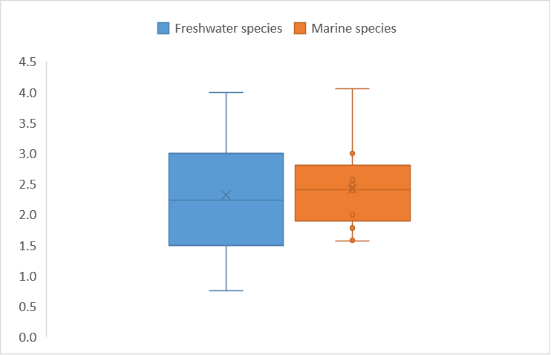

Organism type

Log-transformed toxicity data

Figure B 1 Box plot, comparing freshwater and marine species sensitivities to simazine. Note: the line in the box represents the median; ‘x’ represents the mean; unfilled circles represent suspected outliers; filled circles represent known outliers; error bars represent minimum and maximum values.

Calculation of the bimodality coefficient (BC) yielded a value of 0.422, which is below the indicative threshold of 0.55, suggesting the dataset does not exhibit bimodality. A frequency histogram of the dataset (Figure B 2) indicates that the dataset may not be unimodal.

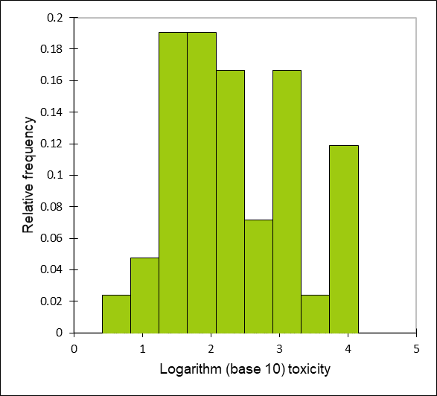

Figure B 2 Histogram, log-transformed ecotoxicity data for freshwater and marine species

##### Do data show taxa-specific sensitivity (i.e. through distinct groupings of different taxa types)?

The relative sensitivity of phototrophs and heterotrophs to simazine was compared using box and whisker plots (Figure B 3) and a species sensitivity distribution (SSD) (Figure B 4). These visual analyses indicate that there is not a complete separation in the sensitivity of phototrophs and heterotrophs to simazine. Note that the SSD does not fit the heterotroph data as well as the phototroph data (Figure B 3) although overall the SSD fits the combined phototroph and heterotroph ecotoxicity data well.

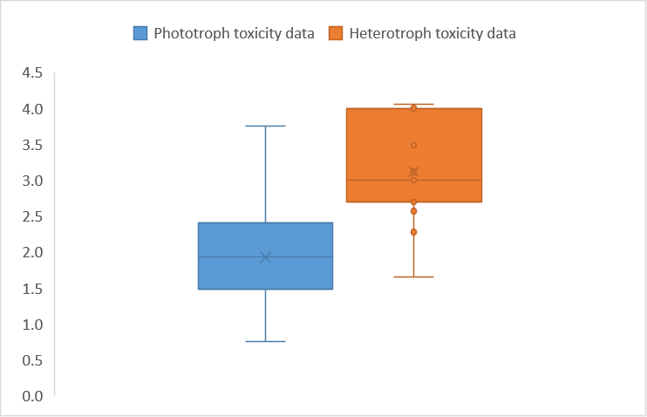

Medium type

Log-transformed toxicity data

Figure B 3 Box and whisker plots, comparison of phototroph and heterotroph sensitivity to simazine. Note: the line in the box represents the median; ‘x’ represents the mean; unfilled circles represent suspected outliers; filled circles represent known outliers; error bars represent minimum and maximum values.

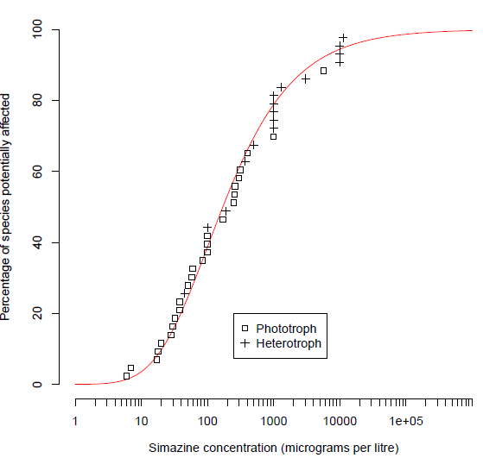

Figure B 4 Species sensitivity distribution, phototroph and heterotroph sensitivity to simazine

##### Is it likely that indications of bimodality, or multimodality or distinct clustering of taxa groups are not due to artefacts of data selection, small sample size, test procedures, or other reasons unrelated to a specific mode of action?

Given that there are data for 27 phototrophs and 15 heterotrophs, it is likely that the distributions are representative.

The only line of evidence that supports a bimodal distribution of species sensitivity to simazine is based on the mode of action of simazine (which leads to increased sensitivity of photosynthetic organisms). Overall, the available evidence suggests the sensitivity of simazine is likely to be unimodal. Therefore, ecotoxicity data for all species were used to derive DGVs for simazine as per Warne et al. (2018). This decision about the modality of simazine ecotoxicity data is consistent with that for atrazine.

## References

ALA (2017) [Atlas of Living Australia](https://www.ala.org.au/) [website], National Research Infrastructure for Australia and Commonwealth Scientific and Industrial Research Organisation.

Allinson G, Zhang P, Bui AD, Allinson M, Rose G, Marshall S and Pettigrove V (2015) ‘Pesticide and trace metal occurrence and aquatic benchmark exceedances in surface waters and sediments of urban wetlands and retention ponds in Melbourne, Australia’, *Environmental Science Pollution and Research*, 22:10214–10226.

ANZECC/ARMCANZ (2000) *Australian and New Zealand Guidelines for Fresh and Marine Water Quality,* Australian and New Zealand Environment and Conservation Council and Agriculture and Resource Management Council of Australia and New Zealand.

ANZG (2018) [*Australian and New Zealand Guidelines for Fresh and Marine Water Quality*](https://www.waterquality.gov.au/anz-guidelines) [website], Australian and New Zealand Governments and Australian state and territory governments.

APVMA (2023) Simazine, [*Australian Pesticides and Veterinary Medicine Authority PubCRIS Database*](https://portal.apvma.gov.au/pubcris), accessed 2024.

Bergman Å, Heindel JJ, Jobling S, Kidd K, Zoeller TR and World Health Organization (2013) *State of the science of endocrine disrupting chemicals 2012*, World Health Organization.

CCME (1999) ‘Canadian water quality guidelines for the protection of aquatic life – Simazine’ [Canadian Council of Ministers of the Environment](https://ccme.ca/en/resources/water-aquatic-life) [webpage].

Chan CY (2005) *Detoxification and degradation of triazine-pollutants by an integrated photochemical-biological system* [PhD thesis], The Chinese University of Hong Kong, China.

Chen S, Yin C, Strasser RJ, Govindjee, Yang C and Qiang S (2012) ‘Reactive oxygen species from chloroplasts contribute to 3-acetyl-5-isopropyltetramic acid-induced leaf necrosis of *Arabidopsis thaliana*’, *Plant Physiology and Biochemistry*, 52:38–51.

Depledge MH and Billinghurst Z (1999) ‘Ecological significance of endocrine disruption in marine invertebrates’, *Marine Pollution Bulletin*, 39:1–12.

Devlin M, Lewis S, Davis A, Smith RA, Negri A, Thompson M and Poggio M (2015) *Advancing our understanding of the source, management, transport and impacts of pesticides on the Great Barrier Reef 2011–2015 (report no. 15/14)*, Centre for Tropical Water and Aquatic Ecosystem Research, Queensland Department of Environment and Heritage Protection.

Faust M, Altenburger R, Backhaus T, Blanck H, Boedeker W, Gramatica P, Hamer V, Scholze M, Vighi M and Grimme LH (2001) ‘Predicting the joint algal toxicity of multi-component s-triazine mixtures at low-effect concentrations of individual toxicants’, *Aquatic Toxicology*, 56:3–32.

Francois DL and Robinson GGC (1990) Indices of triazine toxicity in Chlamydomonas geitleri Ettl. *Aquatic Toxicology*, *16*:205-227.

Guiry MD and Guiry GM (2017) [AlgaeBase](https://www.algaebase.org/) [website], National University of Ireland.

Halliwell B (1991) ‘Oxygen radicals: their formation in plant tissues and their role in herbicide damage’, in Baker NR and Percival MP (eds) *Herbicides*, Elsevier Science, Amsterdam.

ITIS (2017) [Integrated Taxonomic Information System](https://www.itis.gov/), United States Geological Survey and Smithsonian Foundation.

Knauer K, Homazava N, Junghans M and Werner I (2016) ‘The influence of particles on bioavailability and toxicity of pesticides in surface waters’, *Integrated Environmental Assessment and Management*, 13:585–600.

Knuteson SL, Whitwell T and Klaine SJ (2002) ‘Influence of plant age and size on simazine toxicity and uptake’, *Journal of Environmental Quality*, 31:2096–2103.

Ma J (2002) ‘Differential sensitivity to 30 herbicides among populations of two green algae *Scenedesmus obliquus* and *Chlorella pyrenoidosa’,* *Bulletin of Environmental Contamination and Toxicology*, 68:275-281.

Ma J, Lin F, Wang S and Xu L (2003) ‘Toxicity of 21 Herbicides to the green alga *Scenedesmus quadricauda’*, *Bulletin of Environmental Contamination and* Toxicology, 71(3):594–601.

Ma J, Xu L and Wang S (2002a) ‘A quick, simple, and accurate method of screening herbicide activity using green algae cell suspension cultures’, *Weed Science*, 50:555-559.

Ma J, Xu L, Wang S, Zheng R, Jin S, Huang S, and Huang Y (2002b) ‘Toxicity of 40 herbicides to the green alga *Chlorella vulgaris*’, *Ecotoxicology and Environmental Safety*, *51*(2):128–132.

MacBean C and BCPC (2012) *The pesticide manual: a world compendium,* 16th edn*,* British Crop Production Council, Alton.

Ministry for Primary Industries New Zealand (2020) [*Agricultural Compounds and Veterinary Medicines Register*](https://eatsafe.nzfsa.govt.nz/web/public/acvm-register), New Zealand Food Safety website.

Mnif W, Hassine AIH, Bouaziz A, Bartegi A, Thomas O and Roig B (2011) ‘Effect of endocrine disruptor pesticides: a review’, *International Journal of Environmental Research and Public Health*, 8:2265–2303.

Moore A and Lower N (2001) ‘The impact of two pesticides on olfactory-mediated endocrine function in mature male Atlantic salmon (*Salmo salar* L.) parr’, *Comparative Biochemistry and Physiology Part B:* *Biochemistry and Molecular Biology*, 129:269–276.

Oropesa AL, García-Cambero JP and Soler, F (2009a) ‘Effect of a subchronic exposure to simazine on energetic metabolism of Common Carp (*Cyprinus carpio*)’, *Journal of Environmental Science and Health, Part B, Pesticides, Food Contamination and Agricultural Wastes*, 44:144–156.

Oropesa AL, García-Cambero JP, Gomez L, Roncero V and Soler F (2009b) ‘Effect of long-term exposure to simazine on histopathology, hematological, and biochemical parameters in *Cyprinus carpio*’, *Environmental Toxicology*, 24:187–199.

Pérez J, Domingues I, Soares AM, and Loureiro S (2011) ‘Growth rate of *Pseudokirchneriella subcapitata* exposed to herbicides found in surface waters in the Alqueva reservoir (Portugal): a bottom-up approach using binary mixtures’, *Ecotoxicology*, *20*:1167–1175.

Ramel F, Sulmon C, Bogard M, Couée I and Gouesbet G (2009) ‘Differential patterns of reactive oxygen species and antioxidative mechanisms during atrazine injury and sucrose-induced tolerance in *Arabidopsis thaliana* plantlets’, *BMC Plant Biology*, 9:28, doi:10.1186/1471-2229-9-28.

Roskov Y, Abucay L, Orrell T, Nicolson D, Bailly N, Kirk PM, Bourgoin T, DeWalt RE, Decock W, De Wever A, Nieukerken E, Zarucchi J and Penev L (eds) (2017) [C*atalogue of life*](https://www.catalogueoflife.org/) [website], accessed 30 April 2017.

Stara A, Machova J and Velisek J (2012) ‘Effect of chronic exposure to simazine on oxidative stress and antioxidant response in common carp (*Cyprinus carpio* L.)’, *Environmental Toxicology and Pharmacology*, 33:334–343.

Stone WW, Gilliom RJ and Martin JD (2014) [An overview comparing results from two decades of monitoring for pesticides in the Nation’s streams and Rivers, 1992–2001 and 2002–2011: Scientific Investigations Report 2014–5154](https://pubs.usgs.gov/sir/2014/5154/pdf/sir2014-5154.pdf), US Department of the Interior and US Geological Survey.

Sunderam RIM, Warne MStJ, Chapman JC, Pablo F, Hawkins J, Rose RM and Patra RW (2000) The ANZECC/ARMCANZ Water Quality Guideline Database for Toxicants. Supplied as part of CD-ROM in ANZECC/ARMCANZ (2000) Australian and New Zealand Guidelines for Fresh and Marine Water Quality.

University of Hertfordshire 2013. [*The Pesticide Properties DataBase*](http://sitem.herts.ac.uk/aeru/ppdb/en/index.htm). Agriculture and Environment Research Unit, University of Hertfordshire.

USEPA (2015) [ECOTOX Knowledgebase: ECOTOXicology Database System Version 4.0](https://cfpub.epa.gov/ecotox/) [website], United States Environmental Protection Agency.

Vandergragt ML, Warne MStJ, Borschmann G and Johns CV (2020) ‘Pervasive pesticide contamination of wetlands in the Great Barrier Reef Catchment Area’, *Integrated Environmental Assessment and Management*, 16(6):968–982.

Wallace R, Huggins R, King O, Gardiner R, Thomson B, Orr DN, Ferguson B, Taylor C, Smith RA, Warne MStJ, Turner RDR and Mann RM (2016) [Total suspended solids, nutrient and pesticide loads (2014–2015) for rivers that discharge to the Great Barrier Reef – Great Barrier Reef catchment loads monitoring program](https://www.reefplan.qld.gov.au/__data/assets/pdf_file/0035/45989/2014-2015-gbr-catchment-loads-technical-report.pdf) [PDF 2,898KB], [Modelling and monitoring | Reef 2050 Water Quality Improvement Plan (reefplan.qld.gov.au)](https://www.reefplan.qld.gov.au/tracking-progress/paddock-to-reef/modelling-and-monitoring). Queensland Department of Environment, Science and Innovation.

Wallace R, Huggins R, Smith RA, Turner R, Garzon-Garcia A and Warne MStJ (2015) [*Total suspended solids, nutrient and pesticide loads (2012–2013) for rivers that discharge to the Great Barrier Reef – Great Barrier Reef catchment loads monitoring program 2012–2013*](https://www.reefplan.qld.gov.au/__data/assets/pdf_file/0031/45985/2012-2013-gbr-catchment-loads-technical-report.pdf) [PDF 2 897KB], [Modelling and monitoring | Reef 2050 Water Quality Improvement Plan (reefplan.qld.gov.au)](https://www.reefplan.qld.gov.au/tracking-progress/paddock-to-reef/modelling-and-monitoring). Queensland Department of Environment, Science and Innovation.

Warne MStJ (2001) *Description of how each toxicant trigger value was derived*. CD-ROM provided with ANZECC/ARMCANZ (2000) Australian and New Zealand Guidelines for Fresh and Marine Water Quality, Canberra.

Warne MStJ, Batley GE, van Dam RA, Chapman JC, Fox DR, Hickey CW and Stauber JL (2018) *Revised method for deriving Australian and New Zealand water quality guideline values for toxicants – update of 2015 version,* Australian and New Zealand Governments and Australian state and territory governments.

Warne MStJ, Smith RA and Turner RDR (2020) ‘Analysis of mixtures of pesticides discharged to the Great Barrier Reef, Australia’, *Environmental Pollution*,265:114088*.*

Warne MStJ, Westbury AM and Sunderam R (1998) ‘A compilation of toxicity data for chemicals to Australasian aquatic species. Part 1: Pesticides’, *Australasian Journal of Ecotoxicolog*y, 4:93–144.

Wilkinson AD, Collier CJ, Flores F, Langlois L, Ralph PJ and Negri AP (2017) ‘Combined effects of temperature and the herbicide diuron on photosystem II activity of the tropical seagrass *Halophila ovalis*’, *Scientific Reports*, 7(1):45404.

Wilson PC, Whitwell T and Klaine SJ (2000a) ‘Metalaxyl and simazine toxicity to and uptake by *Typha latifolia*’ *Archives of Environmental Contamination and Toxicology*, 39(3):282–288.

Wilson PC, Whitwell T, and Klaine SJ (2000b) ‘Phytotoxicity, uptake, and distribution of 14C-simazine in *Acorus gramenius* and *Pontederia cordata*’, *Weed Science*, 48:701-709.

Wilson PC and Wilson SB (2010) ‘Toxicity of the herbicides bromacil and simazine to the aquatic macrophyte, *Vallisneria americana* Michx’, *Environmental Toxicology and Chemistry*, 29:201–211.

WoRMS (2017) [World Register of Marine Species](https://www.marinespecies.org/) [website], WoRMS Editorial Board.