# Toxicant default guideline values for aquatic ecosystem protection

Simazine in marine water

Technical brief

February 2025

© Commonwealth of Australia 2025

**Ownership of intellectual property rights**

Unless otherwise noted, copyright (and any other intellectual property rights, if any) in this publication is owned by the Commonwealth of Australia (referred to as the Commonwealth).

**Creative Commons licence**

All material in this publication is licensed under a Creative Commons Attribution 4.0 Australia Licence, save for content supplied by third parties, photographic images, logos and the Commonwealth Coat of Arms.

by  
Creative Commons Attribution 4.0 Australia Licence is a standard form licence agreement that allows you to copy, distribute, transmit and adapt this publication provided you attribute the work. See the [summary of the licence terms](https://creativecommons.org/licenses/by/4.0/) or the [full licence terms](https://creativecommons.org/licenses/by/4.0/legalcode).

Inquiries about the licence and any use of this document should be emailed to [copyright@dcceew.gov.au](mailto:copyright@dcceew.gov.au).

**Cataloguing data**

This publication (and any material sourced from it) should be attributed as: ANZG 2025, *Toxicant default guideline values for aquatic ecosystem protection: Simazine in marine water.* Australian and New Zealand Guidelines for Fresh and Marine Water Quality. CC BY 4.0. Australian and New Zealand Governments and Australian state and territory governments, Canberra, ACT, Australia.

This publication is available at [waterquality.gov.au/anz-guidelines/guideline-values/default/water-quality-toxicants/toxicants](http://www.waterquality.gov.au/anz-guidelines/guideline-values/default/water-quality-toxicants/toxicants).

**Contact**

Australian Government Department of Climate Change, Energy, the Environment and Water

GPO Box 858 Canberra ACT 2601

General enquiries: 1800 920 528

Email [waterquality@dcceew.gov.au](mailto:waterquality@dcceew.gov.au)

**Disclaimer**

The author(s) of this publication, all other entities associated with funding this publication or preparing and compiling this publication, and the publisher of this publication, and their employees and advisers, disclaim all liability, including liability for negligence and for any loss, damage, injury, expense or cost incurred by any person as a result of accessing, using or relying on any of the information or data in this publication to the maximum extent permitted by law.

**Acknowledgements**

The default guideline values (DGVs) were derived by Olivia C King (NSW Department of Climate Change, Energy, the Environment and Water), Dr Rachael A Smith (Queensland Department of Environment, Tourism, Science and Innovation (DETSI)), Gabrielle Dern (Griffith University) and Dr Michael St J Warne (University of Queensland). The DGVs were peer reviewed by two anonymous reviewers, by Dr Reinier M Mann (DETSI) and by contracted technical advisors Dr Rick van Dam and Dr Melanie Trenfield.



Contents

Summary v

1 Introduction 1

2 Aquatic toxicology 2

2.1 Mechanism of toxicity 2

2.2 Relative toxicity 2

3 Factors affecting toxicity 3

4 Default guideline value derivation 4

4.1 Toxicity data used in derivation 4

4.2 Species sensitivity distribution 7

4.3 Default guideline values 7

4.4 Reliability classification 8

Glossary 9

Appendix A: Toxicity data that passed the screening and quality assessment and were used to derive the default guideline values 11

Appendix B: Modality assessment for simazine toxicity to aquatic species 14

Appendix C: Explanation of the dataset used to derive the DGVs 17

References 19

Figures

Figure 1 Structure of simazine 1

Figure 2 Species sensitivity distribution, simazine in marine water 7

Tables

Table 1 Summary, selected physico-chemical properties of simazine 1

Table 2 Summary of single toxicity values, all species used to derive the default guideline values for simazine in marine water 5

Table 3 Default guideline values, simazine in marine water, moderate reliability 8

Appendix figures

Figure B 1 Box plot, comparison of freshwater and marine species sensitivities to simazine 14

Figure B 2 Histogram of freshwater and marine species dataset 15

Figure B 3 Box plot, comparison of phototroph and heterotroph sensitivity to simazine 15

[Figure B 4 Species sensitivity distribution, comparison of phototroph and heterotroph sensitivity  
to simazine 16](#_Toc189412396)

Figure C 1 Species sensitivity distribution, first dataset, simazine in marine water 17

Figure C 2 Species sensitivity distribution, second dataset, simazine in marine water 18

Appendix tables

Table A 1 Summary, toxicity data that passed the screening and quality assurance processes, simazine in marine water 11

Table C 1 Protective concentrations, first dataset, simazine in marine water, moderate reliability 17

[Table C 2 Protective concentrations, second dataset, simazine in marine water, moderate  
reliability 18](#_Toc189412407)

## Summary

The default guideline values (DGVs) and associated information in this technical brief should be used in accordance with the detailed guidance provided in the Australian and New Zealand Guidelines for Fresh and Marine Water Quality website (www.waterquality.gov.au/anz-guidelines).

Simazine (6-chloro-N2,N4-diethyl-1,3,5-triazine-2,4-diamine, CAS no. 122-34-9) is a selective, systemic triazine herbicide or, more specifically, a chlorotriazine herbicide. Other chlorotriazine herbicides include atrazine, propazine and terbuthylazine. Simazine is a photosynthesis-inhibiting herbicide commonly used to control a large variety of weeds in agriculture (for specific cropping and non-cropping purposes), forestry and a range of urban and industrial settings (ACVM 2020; APVMA 2020).

The previous DGV for simazine in marine water was a low reliability value (using ANZECC/ARMCANZ (2000)) and was adopted from the freshwater DGV, which was based on acute toxicity data for 12 phototrophs and heterotrophs from four taxonomic groups (i.e. fish, crustaceans, insects and algae) (Warne 2001). More data on simazine toxicity to marine species are now available, enabling the calculation of more reliable DGVs.

Simazine has a specific mode of action (inhibition of the photosystem II pathway) and a non-specific mode of action (formation of reactive oxygen species) and can exert biochemical effects such as endocrine disruption in other non-target organisms. Because of its specific mode of action, low simazine concentrations should be more toxic to phototrophs than heterotrophs. However, the various lines of evidence (Appendix B) indicate no difference in the sensitivity of phototrophs and heterotrophs; therefore, the DGVs were derived using toxicity data for both phototrophs and heterotrophs. The lowest reported chronic toxicity value to marine species is 37.5 µg/L (microalga, 72-h NEC/EC10) and the lowest reported acute toxicity value to marine species is 1 000 µg/L (fish, 96-h LOEL).

Moderate reliability DGVs for simazine in marine water were derived based on chronic, chronic estimated and converted acute negligible effect data (i.e. chronic 10% effect concentration (EC10), chronic 10% inhibition concentration (IC10), chronic no effect concentration (NEC), chronic no observed effect level (NOEL)) and acute 50% lethal concentration (LC50) converted to chronic EC10 or NOEL) for 14 species from seven phyla, with a good fit of the species sensitivity distribution to the toxicity data. The DGVs apply to the active ingredient (simazine) rather than commercial formulations. The DGVs for 99%, 95%, 90% and 80% species protection are 15 µg/L, 30 µg/L, 47 µg/L and 84 µg/L, respectively. The 95% species protection DGV is recommended for application to slightly-to-moderately disturbed ecosystems.

## Introduction

Simazine is a triazine herbicide (C7H12ClN5) (Figure 1). It is the active ingredient of a variety of commercial herbicide formulations. Simazine is often mixed with other herbicides (e.g. ametryn, atrazine, diuron, metolachlor and paraquat) to increase its efficacy. Physico-chemical properties of simazine that may affect its environmental fate and toxicity are presented in Table 1.

Diagram displays the chemical structure of simazine.

Figure 1 Structure of simazine

Table 1 Summary, selected physico-chemical properties of simazine

|  |  |
| --- | --- |
| Physico-chemical property | Value |
| Molecular weight | 201.7 amu **a** |
| Aqueous solubility | 6.2 mg/L at pH 7 and 22°C **a**  5 mg/L at 20°C **b** |
| Logarithm of the octanol-water partition coefficient (log Kow) | 2.1 **a**  2.3 at pH 7 20°C **b** |
| Logarithm of the organic carbon water partition coefficient (log Koc) | 2.20 **a**  2.14 at 25°C **b** |
| Logarithm of the bioconcentration factor (log BCF) | 2.34 **b**  <2.0 **c** |
| Half-life in water (t1/2) | Freshwater: 8.8 d at pH 1, 96 d at pH 5, 3.7 d at pH 13 **a**  Marine: 29 d (light), 49 d (dark)at 20°C) **d**, 96 d at pH 7 and 20°C **b** |
| Half-life in soils (t1/2) | 90 d (measured in the field) **b** |

**a** BCPC (2012).

**b** University of Hertfordshire (2013).

**c** CCME (1999).

**d** Navarro et al. (2004).

Simazine belongs to the chlorotriazine group within the triazine herbicides, which also include atrazine, propazine and terbuthylazine. Simazine is a pre-emergent herbicide and is used as both a knockdown and residual herbicide. In Australia and New Zealand, simazine is approved for weed control in agriculture (e.g. apples, asparagus, berries, broad beans, chick peas, citrus, grapes, lucerne, pears and wheat), forestry, and a range of urban and industrial uses (e.g. weed control around buildings, drains, roadsides, footpaths and other commercial and public land) (ACVM 2020; APVMA 2020).

Simazine has poor-to-moderate soil binding characteristics due to its low log Koc value (Table 1). Although simazine is used in terrestrial applications, its presence in marine habitats demonstrates its mobility and long half-life in aquatic marine environments (Table 1). Simazine has been detected frequently in Australian estuarine, coastal and marine ecosystems, including the Great Barrier Reef (Shaw and Müller 2005), seagrass communities in Hervey Bay (McMahon et al. 2005), and mangrove forest in the Mackay Whitsundays (Duke et al. 2005). Following a withdrawal of authorisations of plant protection products containing simazine in Europe in 2003 (EU Commission Regulation 2010), simazine was still detectable in marine ecosystems almost a decade later, although well below the levels from one to two decades earlier (Mai et al. 2013). Due to its widespread detection and its broad range of adverse effects, simazine has been included in the EU Priority Pollutants List and the equivalent United States Environmental Protection Agency (USEPA) list (Stara et al. 2012).

## Aquatic toxicology

### Mechanism of toxicity

Simazine is mainly absorbed through the roots of plants and transported to the leaves, where it exerts its toxicity. Simazine exerts its toxicity in aquatic plants (including macrophytes and algae) by inhibiting electron transport in the photosystem II (PSII) complex (University of Hertfordshire 2013), a key process in photosynthesis that occurs in the thylakoid membranes of chloroplasts. Photosynthesis-inhibiting herbicides bind to the plastoquinone B protein binding site on the D1 protein in PSII. This prevents the transport of electrons to synthesise adenosine triphosphate (used for cellular metabolism) and nicotinamide adenine dinucleotide phosphate (used in converting CO2 to glucose), therefore preventing CO2 fixation (Wilson et al. 2000).

In addition to its main mechanism of toxicity, exposure to PSII-inhibiting herbicides can increase the formation of reactive oxygen species (ROS), including the singlet oxygen (1O2), superoxide (O2–) and hydrogen peroxide (H2O2) (Halliwell 1991). ROS are highly reactive forms of oxygen that readily react with, and bind to, biomolecules, including deoxyribonucleic acid (DNA) and ribonucleic acid (RNA). ROS are created during normal cellular functions, particularly in biochemical processes that involve the generation of energy (e.g. photosynthesis in chloroplasts; Krebs cycle in mitochondria), and are involved in a number of cellular processes (Chen et al. 2012). In phototrophs, ROS are formed when the absorbed light energy exceeds the ability to convert CO2 to organic molecules, thus accumulating oxygen (Chen et al. 2012). Prolonged exposure to elevated concentrations of ROS in plants, generated by biotic (e.g. disease) and/or abiotic (e.g. PSII-inhibiting herbicides) stressors, can cause irreversible cell damage and ultimately lead to cell death (apoptosis).

While simazine predominantly targets the PSII complex, it can also exert biochemical effects (including endocrine disrupting effects) in non-target organisms (Depledge and Billinghurst 1999; Mnif et al. 2011; Bergman et al. 2013). For example, concentrations of 1–2 µg/L can inhibit the endocrine-mediated olfactory response of male Atlantic salmon (*Salmo salar* L.) to the female priming pheromone prostaglandin (Moore and Lower 2001).

### Relative toxicity

There were toxicity data for 15 marine species that passed the screening and quality assessment processes. These consisted of 10 phototrophs and five heterotrophs. The phototrophs consisted of three diatoms, three green algae, one cryptomonad, two golden-brown microalgae and a dinoflagellate. The heterotrophs consisted of three crustaceans and a mollusc (bivalve). The sparse availability of simazine toxicity to marine species data limits the ability to compare its relative toxicity among different organism types. Generally, heterotrophs were less sensitive than phototrophs, although there was overlap in the datasets, with two marine heterotroph sensitivities within the range of phototroph sensitivities (Appendix B).

There did not appear to be any difference in the sensitivities of the five types of marine phototrophs as their ranges of toxicity values overlap, as follows.

* Diatom toxicity values ranged from 100 µg/L for *Phaeodactylum tricornutum* (Osborn and Hook 2013) to 250 µg/L for *Skeletonema costatum* (USEPA 2015).
* Green algae toxicity values ranged from 37.5 µg/L for *Tetraselmis* sp. (Negri et al. 2020) to 5 000 µg/L for *Dunaliella tertiolecta* (USEPA 2015).
* Golden-brown algae toxicity values ranged from 60.2 µg/L for *Tisochrysis lutea* (Negri et al. 2020) to 500 µg/L for *Isochrysis galbana* (USEPA 2015).
* Cryptomonad toxicity values ranged from 38.4 µg/L to 184 µg/L for *Rhodomonas salina* (Negri et al. 2020).
* Dinoflagellate toxicity values ranged from 257 µg/L to 387 µg/L for *Cladocopium goreaui* (Negri et al. 2020).

The heterotrophs had toxicity values ranging from 1 000 µg/L to 1 000 000µg/L.

* Fish toxicity values ranged from 1 000 µg/L for *Morone saxatilis* (USEPA 2015) to 4 300 µg/L for *Cyprinodon variegatus* (USEPA 2015).
* Mollusc toxicity values ranged from 1 000 µg/L to 3 700 µg/L for *Crassostrea virginica* (USEPA 2015).
* Crustaceans appeared less sensitive than the other heterotrophs, having toxicity values that ranged from 75 000 µg/L for *Penaeus duorarum* (USEPA 2015) to 1 000 000 µg/L for *Neopanope texana* (USEPA 2015).

Although behavioural and biochemical effects of simazine on heterotrophs have been reported at very low concentrations (e.g. Moore and Lower 2001; Section 2.1), the ecological relevance of these endpoints is unclear. Consequently, such data were not used to derive the DGVs (as per Warne et al. 2018).

## Factors affecting toxicity

As with many organic chemicals, it might be expected that dissolved and particulate organic matter and suspended solids would affect simazine bioavailability and toxicity. However, any such effect would be relatively minor given the relatively low log Koc value of simazine. As noted in Section 2.1, one of the modes of action of simazine is to increase the formation of ROS. Given that the formation of ROS depends on the presence of light, it is plausible that increased turbidity (e.g. from suspended solids) could decrease simazine toxicity. However, there appear to be no available published data on this potential toxicity modifying factor for simazine. The information on this potential toxicity modifying factor for other PSII herbicides is contradictory. Knauer et al. (2016) concluded that the presence of suspended solids did not significantly decrease the toxicity of a range of pesticides, including atrazine (a PSII herbicide) to freshwater species. In contrast, Wilkinson et al. (2017) found that decreased light intensity had a significant antagonistic effect on the toxicity of diuron (another PSII herbicide) to the seagrass *Halophila ovalis*.

## Default guideline value derivation

The DGVs were derived in accordance with the method described in Warne et al. (2018) and using Burrlioz 2.0 software.

### Toxicity data used in derivation

Scientific literature was searched to obtain data for simazine toxicity to marine organisms. In addition, the following databases were searched: ECOTOX Knowledgebase (USEPA 2015); Australasian Ecotoxicology Database (Warne et al. 1998); and ANZECC/ARMCANZ (2000) and Sunderam et al. (2000) toxicant databases. Compared to when the ANZECC/ARMCANZ (2000) simazine DGVs were derived, there are now more simazine toxicity data available (Appendix A). However, chronic toxicity data are still limited (i.e. *n* = 11). To derive higher reliability DGVs in the future, more chronic simazine toxicity tests with marine phototrophs and heterotrophs should be conducted. Despite this, the overall marine (acute and chronic) toxicity dataset exceeded the minimum data requirements to derive DGVs, and freshwater toxicity data were not required to supplement the marine dataset.

There were toxicity data (acute and chronic) for 14 marine species (10 phototrophs and four heterotrophs representing seven phyla and 11 classes) that passed the screening and quality assessment processes. The represented phyla were Arthropoda, Bacillariophyta, Chlorophyta, Cryptophyta, Dinoflagellata, Haptophyta and Mollusca. The 11 classes were Bacillariophyceae (diatoms; major group of algae), Bivalvia (group of molluscs), Chlorophyceae (major group of green microalgae), Chlorodendrophyceae (major group of chlorophyta), Coccolithophyceae (class of yellow algae), Cryptophyceae (group of algae commonly known as cryptomonads), Dinophyceae (class of dinoflagellates), Malacostraca (larger group of crustaceans), Mediophyceae (algae group), Prymnesiophyceae (group of haptophytes) and Chlorodendrophyceae (group of green microalgae). The dataset consisted of chronic toxicity data for 11 species (10 phototrophs and one heterotroph) and acute toxicity data for three species (heterotrophs).

Normally, species classified only to genus (e.g. *Chlorococcum*sp.) are not used in the DGV derivation, as ambiguity at the genus level could result in more than one toxicity value being assigned to a single species. However, visual identification and classification of species within a genus, particularly for microalgae, can be difficult for some genera due to their lack of characteristic morphological features (Kessler and Huss 1992). When there are no other data for species belonging to the same genus (i.e. there is no chance of duplicating a species) and/or when there are limited toxicity data available, genus level data can be included in the DGV derivation. Data for the green algae *Chlorococcum*sp*.* and *Tetraselmis*sp. were considered acceptable for inclusion in the final toxicity dataset as no other toxicity data for either genus were available. Additionally, there were two acute LC50 values reported as ‘greater than’ (>) values that were considered acceptable. Warne et al. (2018) state that > toxicity values can be used provided that:

* there are no available normal (not > or <) values for the same combination of species, measure and endpoint
* they are used as is (e.g. > 50 µg/L would be changed to 50 µg/L in all subsequent calculations).

As there were no other available toxicity data for *Neopanope texana* and *Palaemonetes kadiakensis*, their > LC50 values were included in the final dataset. Such data are deemed acceptable for use because they provide a conservative estimate of the toxicity.

As noted in Section 2, the specific mode of action of simazine on plant photosynthesis indicates that phototrophs might be more sensitive than heterotrophs. To assess this possibility, a modality assessment of the simazine toxicity data (to marine and freshwater species) was undertaken according to the weight of evidence approach described by Warne et al. (2018). Most lines of evidence supported the conclusion that the dataset was unimodal, with no clear difference between the sensitivity of phototrophs and heterotrophs (Appendix B). Therefore, as recommended by Warne et al. (2018), toxicity data for all available organisms were used to calculate the DGVs.

The acceptable dataset comprised marine chronic, chronic estimated and converted acute negligible effect data (e.g. NOEL/NOEC, NEC, EC10) for 14 species. A dataset of exclusively chronic negligible effect data or a combination of chronic negligible effect and measurable effect data (e.g. LOEC and EC50/LC50) was not used because the distribution of these datasets was poor (Appendix C). The acceptable dataset met the minimum data requirements (i.e. at least five species belonging to at least four phyla) to use a species sensitivity distribution to derive DGVs (Warne et al. 2018).

A summary of the toxicity data (one value per species) used to calculate the DGVs for simazine in marine water is in Table 2, with additional details of the data provided in Appendix A. Details of the data quality assessment and the data that passed the quality assessment are provided as supporting information.

Table 2 Summary of single toxicity values, all species used to derive the default guideline values for simazine in marine water

| Taxonomic group (phylum) | Species | Life stage | Duration (days) | Test type | Toxicity measure **a** (endpoint) | Reported toxicity value (µg/L) | Final toxicity value (µg/L) |
| --- | --- | --- | --- | --- | --- | --- | --- |
| Diatom (Bacillariophyta) | *Ceratoneis closterium* **d** | Exponential growth phase | 3 | Chronic | IC10  (Growth rate) | 310 | 310 |
| Green microalga (Chlorophyta) | *Chlorococcum* sp. | – | 10 | Chronic | EC50  (Cell density) | 2 000 | 400 **b** |
| Bivalve (Mollusca) | *Crassostrea virginica* | Spat | 7 | Chronic | NOEL  (Mortality, abnormal development) | 1 000 | 1 000 |
| Dinoflagellate (Dinoflagellata) | *Cladocopium goreaui* | Exponential growth phase | 14 | Chronic | EC10  (Growth rate) | 257 | 257 |
| Green microalga (Chlorophyta) | *Dunaliella tertiolecta* | – | 10 | Chronic | EC50  (Cell density) | 5 000 | 1 000 **b** |
| Golden-brown microalga (Haptophyta) | *Isochrysis galbana* | – | 10 | Chronic | EC50  (Cell density) | 500 | 100 **b** |
| Crustacean (Arthropoda) | *Neopanope texana* | – | 4 | Acute | LC50  (Mortality) | 1 000 000 | 100 000 **c** |
| Crustacean (Arthropoda) | *Palaemonetes kadiakensis* | – | 2 | Acute | LC50  (Mortality) | 100 000 | 10 000 **c** |
| Crustacean (Arthropoda) | *Penaeus duorarum* | – | 4 | Acute | LC50  (Mortality) | 113 000 | 11 300 **c** |
| Diatom (Bacillariophyta) | *Phaeodactylum tricornutum***d** | Exponential growth phase | 3 | Chronic | IC10  (Growth rate) | 100 | 100 |
| Cryptomonad (Cryptophyta) | *Rhodomonas salina* | Exponential growth phase | 3 | Chronic | EC10  (Growth rate) | 38.4 | 38.4 |
| Diatom (Bacillariophyta) | *Skeletonema costatum***d** | – | 5 | Chronic | NOEL  (Cell density) | 250 | 250 |
| Green microalga (Chlorophyta) | *Tetraselmis* sp. | Exponential growth phase | 3 | Chronic | NEC/EC10  (Growth rate) | 37.5 | 37.5 |
| Golden-brown microalga (Haptophyta) | *Tisochrysis lutea* | Exponential growth phase | 3 | Chronic | EC10  (Growth rate) | 60.2 | 60.2 |

**a** The measure of toxicity that is being estimated/determined. NOEL: no observed effect level; NEC: no effect concentration; EC10: 10% effect concentration; IC10: inhibition concentration.

**b** Chronic EC50 values converted to chronic EC10/NOEC values by dividing by 5 (Warne et al. 2018).

**c** Acute LC50 values that were converted to chronic EC10/NOEL values by dividing by 10 (Warne et al. 2018).

**d** Species that originated from or are distributed in Australia and/or New Zealand.

To identify species that were regionally relevant to Australia and New Zealand ecosystems, the following databases were searched: AlgaeBase (Guiry and Guiry 2017); Atlas of Living Australia (ALA 2017); Catalogue of Life (Roskov et al. 2017); Integrated Taxonomic Information System (ITIS 2017); and World Register of Marine Species (WoRMS 2017). The dataset used in the DGV derivation for simazine in marine water (Table 2) includes toxicity data for three marine species that either originated from or are distributed within Australia and/or New Zealand. There were some additional studies that contained simazine toxicity data for Australasian marine species; however, they measured photosynthetic inhibition, which is not accepted as an ecologically relevant endpoint (Warne et al. 2018), and they were not included in the DGV derivation.

### Species sensitivity distribution

The cumulative frequency (species sensitivity) distribution (SSD) of the 14 toxicity values that were used to derive the DGVs is presented in Figure 2. The SSD was plotted using the Burrlioz 2.0 software. The model provided a good fit to the data (Figure 2).

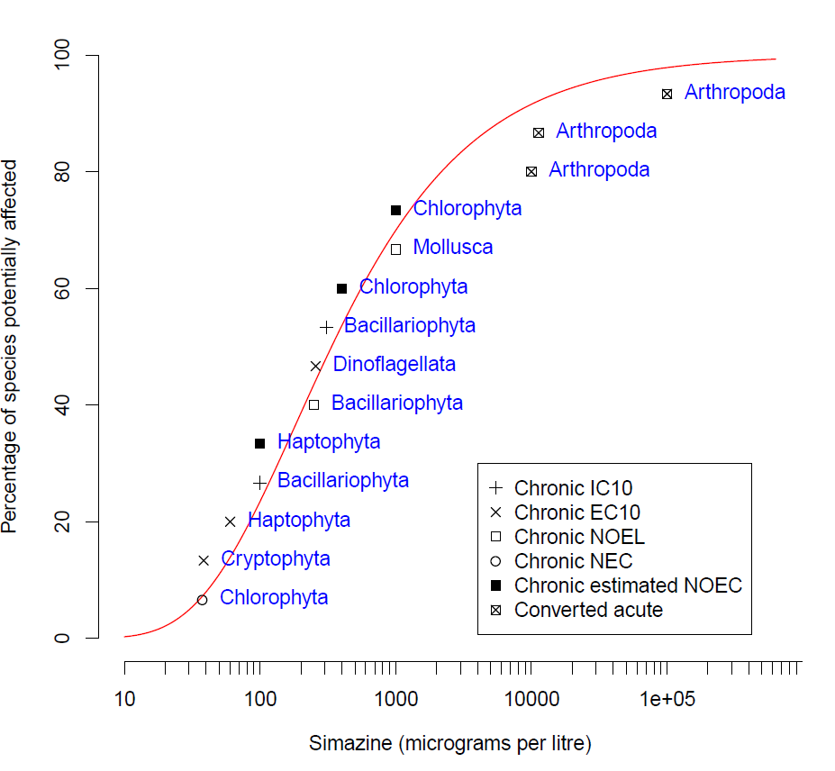

Figure 2 Species sensitivity distribution, simazine in marine water

### Default guideline values

It is important that the DGVs (Table 3) and associated information in this technical brief are used in accordance with the detailed guidance provided in the Australian and New Zealand Guidelines for Fresh and Marine Water Quality website (ANZG 2018).

The DGVs for simazine apply to the concentration of the active ingredient. Although some of the toxicity data used to derive the DGVs may have incorporated toxicity due to simazine metabolites, this has not been quantified; therefore, the DGVs relate to simazine only—not its metabolites.

Measured log BCF values for simazine are low (Table 1) and below the threshold at which secondary poisoning must be considered (i.e. log BCF = 4 (Warne et al. 2018)). Therefore, the DGVs for simazine do not account for secondary poisoning.

The DGVs for simazine in marine water are provided in Table 3. The 95% species protection DGV of 30 µg/L is recommended for application to slightly-to-moderately disturbed ecosystems.

Table 3 Default guideline values, simazine in marine water, moderate reliability

| Level of species protection (%) | DGV for simazine in marine water (µg/L) **a** |
| --- | --- |
| 99 | 15 |
| 95 | 30 |
| 90 | 47 |
| 80 | 84 |

**a** Default guideline values were derived using Burrlioz 2.0 software and rounded to two significant figures.

### Reliability classification

The simazine marine DGVs have a moderate reliability classification (Warne et al. 2018) based on the outcomes for the following three criteria:

* sample size—14 (good)
* type of toxicity data—chronic and converted acute
* SSD model fit—good (Inverse Weibull).

## Glossary

| Term | Definition |
| --- | --- |
| acute toxicity | A lethal or adverse sub-lethal effect that occurs as the result of a short exposure period to a chemical relative to the organism’s life span. |
| BCF | Bioconcentration factor. |
| bimodal | When the distribution of the sensitivity of species to a toxicant has two modes. This typically occurs with chemicals with specific modes of action. For example, herbicides are designed to affect plants at low concentrations but most animals are only affected at high concentrations. |
| CAS no. | Chemical Abstracts Service number. Each chemical has a unique identifying number that is allocated to it by the American Chemical Society. |
| chronic toxicity | A lethal or sublethal adverse effect that occurs after exposure to a chemical for a period of time that is a substantial portion of the organism’s life span or an adverse effect on a sensitive early life stage. |
| default guideline value (DGV) | A guideline value recommended for generic application in the absence of a more specific guideline value (e.g. site-specific) in the Australian and New Zealand Guidelines for Fresh and Marine Water Quality. |
| EC50 (median effective concentration) | The concentration of a substance in water or sediment that is estimated to produce a 50% change in the response being measured or a certain effect in 50% of the test organisms relative to the control response, under specified conditions. |
| ECx | The concentration of a substance in water or sediment that is estimated to produce an x% change in the response being measured or a certain effect in x% of the test organisms, under specified conditions. |
| endpoint | The specific response of an organism that is measured in a toxicity test (e.g. mortality, growth, a particular biomarker). |
| guideline value (GV) | A measurable quantity (e.g. concentration) or condition of an indicator for a specific community value below which (or above which, in the case of stressors such as pH, dissolved oxygen and many biodiversity responses) there is considered to be a low risk of unacceptable effects occurring to that community value. Guideline values for more than one indicator should be used simultaneously in a multiple lines of evidence approach. |
| heterotroph | An organism that cannot manufacture its own energy and needs to obtain energy from external sources (i.e. by consuming other organisms). |
| ICx | The concentration of a substance in water or sediment that is estimated to produce an x% inhibition of the response being measured in test organisms relative to the control response, under specified conditions. |
| LC50 (median lethal concentration) | The concentration of a substance in water or sediment that is estimated to be lethal to 50% of a group of test organisms, relative to the control response, under specified conditions. |
| LOEC (lowest observed effect concentration) | The lowest concentration of a material used in a toxicity test that has a statistically significant adverse effect on the exposed population of test organisms as compared with the controls. |
| LOEL (lowest observed effect level) | Synonymous with LOEC. |
| mode of action | The means by which a chemical exerts its toxic effects. For example, triazine herbicides inhibit the photosystem II component of plants’ photosynthesis biochemical reaction. |
| NEC (no effect concentration) | The highest concentration that does not have an effect—this is determined differently to a NOEC. |
| NOEC (no observed effect concentration) | The highest concentration of a material used in a toxicity test that has no statistically significant adverse effect on the exposed population of test organisms as compared with the controls. |
| NOEL (no observed effect level) | Synonymous with NOEC. |
| phototroph | An organism that photosynthesises as its main means of obtaining energy (e.g. plants and algae). |
| PSII | Photosystem II of the photosynthetic biochemical pathway. |
| species (biological) | A group of organisms that resemble each other to a greater degree than members of other groups and that form a reproductively isolated group that will not produce viable offspring if bred with members of another group. |
| SSD (species sensitivity distribution) | A method that plots the cumulative frequency of species’ sensitivities to a toxicant and fits a statistical distribution to the data. From the distribution, the concentration that should theoretically protect a selected percentage of species can be determined. |
| toxicity | The inherent potential or capacity of a material to cause adverse effects in a living organism. |
| toxicity test | The means by which the toxicity of a chemical or other test material is determined. A toxicity test is used to measure the degree of response produced by exposure to a specific level of stimulus (or concentration of chemical) for a specified test period |
| unimodal | Having one mode of distribution (of the sensitivity of species to a toxicant). |

## Appendix A: Toxicity data that passed the screening and quality assessment and were used to derive the default guideline values

Table A 1 Summary, toxicity data that passed the screening and quality assurance processes, simazine in marine water

| Taxonomic group | Species | Life stage | Exposure duration (day) | Test type | Toxicity measure (test endpoint) | Test medium | Temp. (°C) | pH | Concentration (µg/L) | Reference |
| --- | --- | --- | --- | --- | --- | --- | --- | --- | --- | --- |
| Crustacean (Arthropoda) | *Neopanope texana* | – | 4 | Acute | LC50 (Mortality) | Natural filtered or artificial seawater | 23 ± 1 | – | 1 000 000 | USEPA (2015) |
| – | | | | | | | | | 100 000 **b** | **Value used in SSD** |
| Crustacean (Arthropoda) | *Palaemonetes kadiakensis* | – | 2 | Acute | LC50 (Mortality) | Natural filtered or artificial seawater | 23 ± 1 | – | 100 000 | USEPA (2015) |
| – | | | | | | | | | 10 000 **b** | **Value used in SSD** |
| Crustacean (Arthropoda) | *Penaeus duorarum* | – | 4 | Acute | LC50 (Mortality) | Natural filtered or artificial seawater | 23 ± 1 | – | 113 000 | USEPA (2015) |
| – | | | | | | | | | 11 300 **b** | **Value used in SSD** |
| Diatom (Bacillariophyta) | *Ceratoneis closterium* | Exponential growth phase | 3 | Chronic | IC10 (Growth rate) | Filtered (0.45 μm) seawater | 21 ± 2 | 8.2 ± 0.1 | 310 | Hook et al. (2014) |
| – | | | | | | | | | 310 | **Value used in SSD** |
| Diatom (Bacillariophyta) | *Phaeodactylum tricornutum* | Exponential growth phase | 3 | Chronic | IC10 (Growth rate) | Filtered (0.45 μm) seawater | 21 ± 2 | 8.2 ± 0.1 | 100 | Osborn and Hook (2013) |
| – | | | | | | | | | 100 | **Value used in SSD** |
| Diatom (Bacillariophyta) | *Skeletonema costatum* | – | 5 | Chronic | NOEL (Cell density) | Algal nutrient medium | 20–24 ± 2 | – | 250 | USEPA (2015) |
| – | | | | | | | | | 250 | **Value used in SSD** |
| Green microalga (Chlorophyta) | *Chlorococcum* sp. | – | 10 | Chronic | EC50 (Cell density) | Synthetic salt water or filtered natural salt water | 30 ± 5 | 8.0 ± 0.1 | 2 000 | USEPA (2015) |
| – | | | | | | | | | 400 **a** | **Value used in SSD** |
| Green microalga (Chlorophyta) | *Dunaliella tertiolecta* | – | 10 | Chronic | EC50 (Cell density) | Synthetic salt water or filtered natural salt water | 30 ± 5 | 8.0 ± 0.1 | 5 000 | USEPA (2015) |
| – | | | | | | | | | 1 000 **a** | **Value used in SSD** |
| Green microalga (Chlorophyta) | *Tetraselmis* sp. | Exponential growth phase | 3 | Chronic | NEC (Growth rate) | EDTA-free Guillard’s f/2 medium | 27–29 | 8.1–8.2 | 37.5 | Negri et al. (2020) |
| Exponential growth phase | 3 | Chronic | EC10 (Growth rate) | EDTA-free Guillard’s f/2 medium | 27–29 | 8.1–8.2 | 37.5 | Negri et al. (2020) |
| – | | | | | | | | | 37.5 | **Value used in SSD** |
| Cryptomonad (Cryptophyta) | *Rhodomonas salina* | Exponential growth phase | 3 | Chronic | EC10 (Growth rate) | Guillard’s f/2 medium | 26.0 ± 0.6 | 8.5 ± 0.4 | 38.4 | Negri et al. (2020) |
| – | | | | | | | | | 38.4 | **Value used in SSD** |
| Dinoflagellate (Dinoflagellata) | *Cladocopium goreaui* | Exponential growth phase | 14 | Chronic | EC10 (Growth rate) | IMK nutrient media | 27 ± 0.6 | 7.8 ± 0.5 | 257 | Negri et al. (2020) |
| – | | | | | | | | | 257 | **Value used in SSD** |
| Golden-brown microalga (Haptophyta) | *Tisochrysis lutea* | Exponential growth phase | 3 | Chronic | EC10 (Growth rate) | EDTA-free Guillard’s f/2 medium | 27–29 | 7.9–8.3 | 60.2 | Negri et al. (2020) |
| – | | | | | | | | | 60.2 | **Value used in SSD** |
| Golden-brown microalga (Haptophyta) | *Isochrysis galbana* | – | 10 | Chronic | EC50 (Cell density) | Synthetic salt water or filtered natural salt water | 30 ± 5 | 8.0 ± 0.1 | 500 | USEPA (2015) |
| – | | | | | | | | | 100 **a** | **Value used in SSD** |
| Bivalve (Mollusca) | *Crassostrea virginica* | Spat | 7 | Chronic | NOEL (Mortality, abnormal development) | Good quality unfiltered seawater: natural or artificial (with food added) | 20 ± 5 | – | 1 000 | USEPA (2015) |
| – | | | | | | | | | 1 000 | **Value used in SSD** |

**a** Values were chronic EC50 values that were converted to chronic EC10/NOEC values by dividing by 5 (Warne et al. 2018).

**b** Values were acute LC50 values that were converted to chronic EC10/NOEL values by dividing by 10 (Warne et al. 2018).

## Appendix B: Modality assessment for simazine toxicity to aquatic species

A modality assessment was undertaken for simazine according to the weight of evidence approach specified in Warne et al. (2018).

##### Is there a specific mode of action that could result in taxa-specific sensitivity?

Section 2.1 describes the known mechanisms of toxicity of simazine. Briefly, simazine is a PSII-inhibiting herbicide that is expected to be more sensitive to phototrophs than to heterotrophs. However, in addition to its main mode of action, exposure to simazine and other PSII-inhibiting herbicides increases the formation of ROS in both phototrophs and heterotrophs. Moreover, simazine can also exert biochemical effects, including endocrine disruption.

Given the main mode of action of simazine is the inhibition of electron transport in the PSII complex, simazine is expected to be more toxic to phototrophs than to heterotrophs.

##### Does the dataset suggest bimodality?

Modality was assessed using a dataset that combined all freshwater and marine toxicity data that passed the screening and quality assessment (n = 42). This was done to increase the sample size of the dataset being assessed.

All acute data (e.g. LC50) or chronic effect data (e.g. EC50) were converted to chronic negligible effect data (e.g. NEC, EC10, NOEL) using the methods recommended by Warne et al. (2018). Box and whisker plots for the freshwater data and marine data suggested considerable overlap, with an indication that marine species may be slightly less sensitive (Figure B 1).

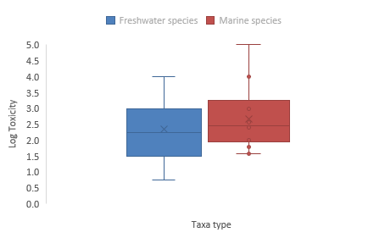

Note: the line in the box represents the median; ‘x’ represents the mean; unfilled circles represent suspected outliers; filled circles represent known outliers; error bars represent minimum and maximum values.

Figure B 1 Box plot, comparison of freshwater and marine species sensitivities to simazine

Calculation of the bimodality coefficient (BC) yielded a value of 0.424. This is below the indicative threshold BC for bimodality of 0.555, suggesting the dataset does not exhibit bimodality (Figure B 2).

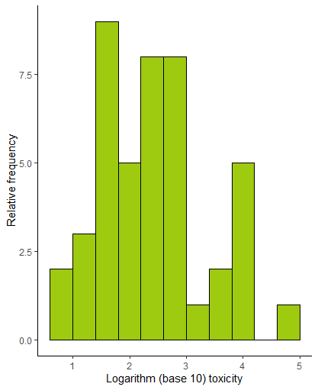

Figure B 2 Histogram of freshwater and marine species dataset

##### Do data show taxa-specific sensitivity (i.e. through distinct groupings of different taxa types)?

The relative sensitivity of freshwater and marine phototrophs and heterotrophs to simazine was compared using box and whisker plots (Figure B 3) and a species sensitivity distribution (SSD) (Figure B 4). These indicated that there is not a complete separation in the sensitivity of phototrophs and heterotrophs to simazine; that is, there is no clear indication of bimodality.

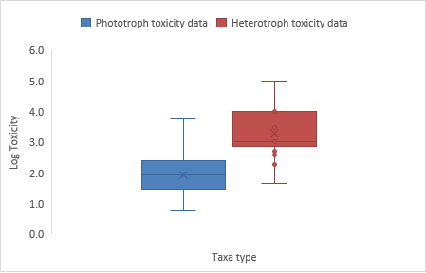

Note: the line in the box represents the median; ‘x’ represents the mean; unfilled circles represent suspected outliers; filled circles represent known outliers; error bars represent minimum and maximum values.

Figure B 3 Box plot, comparison of phototroph and heterotroph sensitivity to simazine

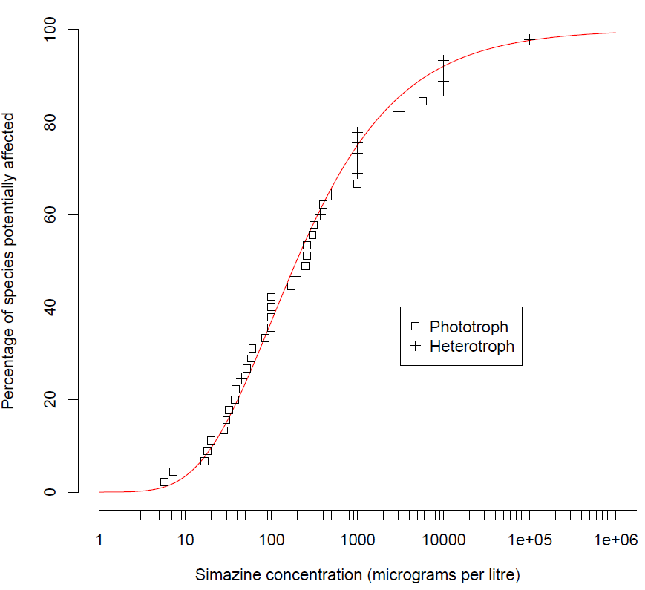

Figure B 4 Species sensitivity distribution, comparison of phototroph and heterotroph sensitivity to simazine

##### **Is it likely that indications of bimodality or multimodality or distinct clustering of taxa groups are not** due to artefacts of data selection, small sample size, test procedures, or other reasons unrelated to a specific mode of action?

Given that there are data for 27 phototrophs and 17 heterotrophs, it is likely that the distributions are representative, although a bias associated with other factors (e.g. data selection, test procedures, or other reasons unrelated to a specific mode of action) cannot be ruled out.

While the specific mode of action of simazine and the frequency histogram in Figure B 2 suggest that simazine toxicity might not be unimodal, this was not well supported by the other lines of evidence. Although simazine might exhibit some taxa-specific sensitivity (i.e. phototrophs being more sensitive that heterotrophs), it does not indicate a distinctly bimodal toxicity relationship.

Overall, the evidence suggests the toxicity of simazine is likely to be unimodal, which is similar to what has been observed for atrazine (a similar herbicide). Therefore, toxicity data for all species were used to derive DGVs for simazine as per Warne et al. (2018).

## Appendix C: Explanation of the dataset used to derive the DGVs

Three datasets were assessed for their suitability to derive DGVs for simazine in marine water.

The first dataset consisted of chronic negligible effect data (i.e. NEC, EC10, IC10, NOEL) for eight marine species that belonged to six phyla, which met the minimum data requirements to derive DGVs using the SSD method. The resulting SSD (Figure C 1) had a poor fit to the data, and protective concentrations (Table C 1) were of moderate reliability.

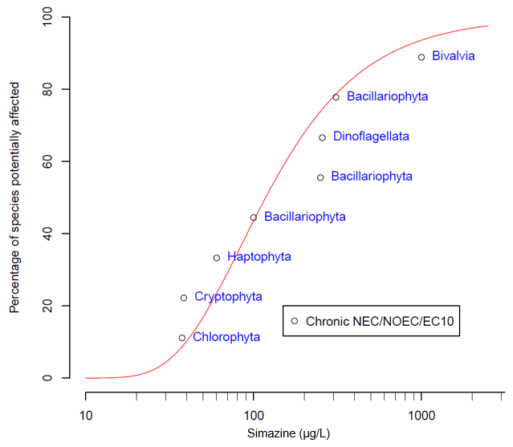

Figure C 1 Species sensitivity distribution, first dataset, simazine in marine water

Table C 1 Protective concentrations, first dataset, simazine in marine water, moderate reliability

| Level of species protection (%) | Protective concentrations for simazine in marine water (µg/L) **a** |
| --- | --- |
| 99 | 21 |
| 95 | 31 |
| 90 | 40 |
| 80 | 55 |

**a** Protective concentrations were derived using Burrlioz 2.0 software and rounded to two significant figures.

The close proximity of the 95% species protection value (31 µg/L) to the two lowest toxicity values (i.e. 37.5 µg/L and 38.4 µg/L, Figure C 1), which represent 25% of the data in the SSD, suggests that the value may not provide adequate protection (i.e. it should protect as few as 75% of species). Under such circumstances, Warne et al. (2018) recommend that a more conservative value is adopted. Another limitation of this dataset is that the fit of the SSD to the data is poor, with the resulting protection concentration values having a moderate reliability if they were used as DGVs.

Given the above limitations, a second dataset was created by including chronic EC50 data that had been converted to chronic negligible effect data based on Warne et al. (2018) to determine if a better fitting SSD and, therefore higher reliability DGVs, could be generated. In doing this, toxicity data for an additional three species were added. The fit of the SSD to the data remained poor (Figure C 2) with the resulting values (Table C 2) having a moderate reliability if they were used as DGVs.

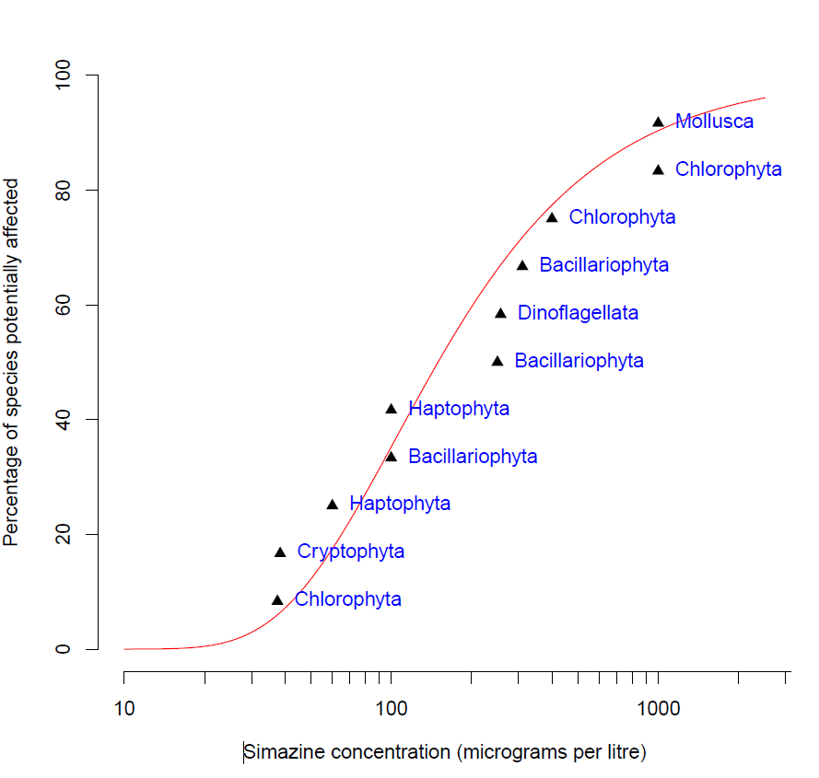

Figure C 2 Species sensitivity distribution, second dataset, simazine in marine water

Table C 2 Protective concentrations, second dataset, simazine in marine water, moderate reliability

| Level of species protection (%) | Protective concentrations for simazine in marine water (µg/L) **a** |
| --- | --- |
| 99 | 23 |
| 95 | 35 |
| 90 | 46 |
| 80 | 65 |

**a** Protective concentrations were derived using Burrlioz 2.0 software and rounded to two significant figures.

The resulting SSD and protective concentrations had the same limitations as using only chronic negligible effect toxicity data; therefore, a third dataset was tested. This involved the use of all available toxicity data to marine species (i.e. for chronic, chronic estimated and converted acute negligible effect toxicity data). The resulting SSD (Figure 2) and values provided a better fit to the data and, as such, these values were recommended for adoption as the DGVs (Table 3).

## References

ACVM (2020) [Agricultural Compounds and Veterinary Medicines register](https://eatsafe.nzfsa.govt.nz/web/public/acvm-register) [website], Ministry for Primary Industries New Zealand, accessed: 10 January 2020.

ALA (2017) [Atlas of Living Australia](https://www.ala.org.au/) [website], National Research Infrastructure for Australia and Commonwealth Scientific and Industrial Research Organisation, accessed May 2017.

ANZECC/ARMCANZ (2000) *Australian and New Zealand guidelines for fresh and marine water quality*, Australian and New Zealand Environment and Conservation Council and Agriculture and Resource Management Council of Australia and New Zealand.

ANZG (2018) [*Australian and New Zealand Guidelines for Fresh & Marine Water Quality*](https://www.waterquality.gov.au/anz-guidelines) [website], Australian and New Zealand governments and Australian state and territory governments.

APVMA (2020) Simazine, [*Australian Pesticides and Veterinary Medicine Authority PubCRIS Database*](https://portal.apvma.gov.au/pubcris), accessed 2024.

BCPC (2012) *A world compendium: the pesticide manual*, 16th edn, MacBean C (ed), British Crop Production Council, United Kingdom.

Bergman Å, Heindel JJ, Jobling S, Kidd KA and Zoeller RT (eds) (2013) *State of the science of endocrine disrupting chemicals – 2012*, United Nations Environment Programme and the World Health Organization.

CCME (1999) [Canadian water quality guidelines for the protection of aquatic life – Simazine](https://ccme.ca/en/res/simazine-en-canadian-water-quality-guidelines-for-the-protection-of-aquatic-life.pdf) [pdf],. Canadian Council of Ministers of the Environment, accessed 24 June 2015.

Chen S, Yin C, Strasser RJ, Govinjee, Yang C and Qiang S (2012) ‘Reactive oxygen species from chloroplasts contribute to 3-acetyl-5-isopropyltetramic acid-induced leaf necrosis of *Arabidopsis thaliana*’, *Plant Physiology and Biochemistry*, 52:38–51.

Depledge MH and Billinghurst Z (1999) ‘Ecological significance of endocrine disruption in marine invertebrates’, *Marine Pollution Bulletin*, 39:1–12.

Duke NC, Bell AM, Pederson DK, Roelfsema CM and Nash SB (2005) ‘Herbicides implicated as the cause of severe mangrove dieback in the Mackay region, NE Australia: consequences for marine plant habitats of the GBR World Heritage Area’, *Marine Pollution Bulletin*, 51(1):308–324.

EU Commission Regulation (2010) [*Commission Regulation (EU) No 196/2010 of 9 March 2010 amending Annex I to Regulation (EC) No 689/2008 of the European Parliament and of the Council concerning the export and import of dangerous chemicals*](https://eur-lex.europa.eu/LexUriServ/LexUriServ.do?uri=OJ:L:2010:060:0005:0008:EN:PDF), Official Journal of the European Union, accessed 24 June 2015.

Guiry MD and Guiry GM (2017) [AlgaeBase](https://www.algaebase.org/) [online database], University of Galway, accessed May 2017.

Halliwell B (1991) ‘Oxygen radicals: their formation in plant tissues and their role in herbicide damage’, in Baker NR and Percival MP (eds), *Herbicides*, Elsevier Science, Amsterdam.

Hook SE, Osborn HL, Gissi F, Moncuquet P, Twine NA, Wilkins MR and Adams MS (2014) ‘RNA-seq analysis of the toxicant-induced transcriptome of the marine diatom, *Ceratoneis closterium*’, *Marine Genomics*, 9(16):45–53.

ITIS (2017) [Integrated Taxonomic Information System](https://www.itis.gov/) [online database], accessed: May 2017.

Kessler E and Huss VAR (1992) ‘Comparative physiology and biochemistry and taxonomic assignment of the Chlorella (Chlorophyceae) strains of the culture collection of the University of Texas at Austin’, *Journal of Phycology*, 28:550–553.

Knauer K, Homazava N, Junghans M and Werner I (2016) ‘The influence of particles on bioavailability and toxicity of pesticides in surface waters’, *Integrated Environmental Assessment and Management*, 13:585–600.

Mai C, Theobald N, Lammel G and Hühnerfuss H (2013) Spatial, seasonal and vertical distributions of currently-used pesticides in the marine boundary layer of the North Sea’, *Atmospheric Environment*, 75:92–102.

McMahon K, Nash SB, Eaglesham G, Müller JF, Duke NC and Winderlich S (2005) ‘Herbicide contamination and the potential impact to seagrass meadows in Hervey Bay, Queensland, Australia’, *Marine Pollution Bulletin*, 51(1):325–334.

Mnif W, Hassine AIH, Bouaziz A, Bartegi A, Thomas O and Roig B (2011) ‘Effect of endocrine disruptor pesticides: a review’, *International Journal of Environmental Research and Public Health*, 8:2265–2303.

Moore A and Lower N (2001) ‘The impact of two pesticides on olfactory-mediated endocrine function in mature male Atlantic salmon (*Salmo salar* L.) parr’, *Comparative Biochemistry and Physiology Part B: Biochemistry and Molecular Biology*, 129:269–276.

Navarro S, Vela N, Giménez MJ, Navarro G (2004) ‘Effect of temperature on the disappearance of four triazine herbicides in environmental waters’, *Chemosphere*, 57(1):51–9. doi: 10.1016/j.chemosphere.2004.05.016 PMID:15288199

Negri AP, Templeman S, Flores F, van Dam J, Thomas M, McKenzie M, Stapp L, Kaserzon S, Mann RM, Smith R, Warne MStJ and Mueller J (2020) *Ecotoxicology of pesticides on the Great Barrier Reef for guideline development and risk assessments*, final report to the National Environmental Science Program, Reef and Rainforest Research Centre Limited.

Osborn HL and Hook SE (2013) ‘Using transcriptomic profiles in the diatom *Phaeodactylum tricornutum* to identify and prioritize stressors’, *Aquatic Toxicology*, 138/139:12–25.

Roskov Y, Abucay L, Orrell T, Nicolson D, Bailly N, Kirk PM, Bourgoin T, DeWalt RE, Decock W, De Wever A, Nieukerken E, Zarucchi J and Penev L (eds) (2017) [*Species 2000 & ITIS catalogue of life*](http://www.catalogueoflife.org), Species 2000, Naturalis, Netherlands, accessed 30 April 2017.

Shaw M and Müller JF (2005) ‘Preliminary evaluation of the occurrence of herbicides and PAHs in the Wet Tropics region of the Great Barrier Reef, Australia, using passive samplers’, *Marine Pollution Bulletin*, 51(8):876–881.

Stara A, Machova J and Velisek J (2012) ‘Effect of chronic exposure to simazine on oxidative stress and antioxidant response in common carp (*Cyprinus carpio* L.)’, *Environmental Toxicology and Pharmacology*, 33:334–343.

Sunderam RIM, Warne MStJ, Chapman JC, Pablo F, Hawkins J, Rose RM and Patra RW (2000) *The ANZECC/ARMCANZ water quality guideline database for toxicants*, supplied as CD-ROM in ANZECC/ARMCANZ Australian and New Zealand guidelines for fresh and marine water quality.

University of Hertfordshire (2013) [*PPDB: Pesticide Properties DataBase*](https://sitem.herts.ac.uk/aeru/ppdb/en/index.htm) [website], accessed 3 October 2024.

USEPA (2015) [*ECOTOX Knowledgebase: ECOTOXicology Database System Version 4.0*](https://cfpub.epa.gov/ecotox/) [website], United States Environmental Protection Agency.

Warne MStJ (2001) *Description of how each toxicant trigger value was derived*, supplied as CD-ROM in ANZECC/ARMCANZ Australian and New Zealand guidelines for fresh and marine water quality.

Warne MStJ, Batley GE, van Dam RA, Chapman JC, Fox DR, Hickey CW, and Stauber JL (2018) *Revised method for deriving Australian and New Zealand water quality guideline values for toxicants – update of 2015 version*, Australian and New Zealand governments and Australian state and territory governments.

Warne MStJ, Westbury A-M and Sunderam R (1998) ‘A compilation of toxicity data for chemicals to Australasian aquatic species. Part 1: pesticides’ *Australasian Journal of Ecotoxicology,* 4:93–144.

Wilkinson AD, Collier CJ, Flores F, Langlois L, Ralph PJ and Negri AP (2017) ‘Combined effects of temperature and the herbicide diuron on Photosystem II activity of the tropical seagrass *Halophila ovalis*’, *Scientific Reports*, 7:45404.

Wilson PC, Whitwell T and Klaine SJ (2000) ‘Metalaxyl and simazine toxicity to and uptake by *Typha latifolia*’, *Archives of Environmental Contamination and Toxicology,* 39:282–288.

WoRMS (2017) [*World Register of Marine Species*](https://www.marinespecies.org/) [website], WoRMS Editorial Board, accessed May 2017.